MIS 374 – Business Systems Developer

Spring 2022

By MAVDEV

Ammar Lokhandwala

Maria Frausto

Michael Gurch

Victoria Sheraden

Vivian Bui

TEXAS ASSOCIATION OF CHARITABLE CLINICS (TXACC)

Interim Status Report

**SOFTWARE ACCESS**

**Website**

<https://txacc-resource.mn.co/>

**Admin Access**

Account: [resource@texasacc.org](mailto:resource@texasacc.org)

Password: Axpz!h97_S

SECTION 3A: USER MATERIALS

**Table of Contents**

How to register a new account – without Invitation 2

How to register a new account – with an Invitation 8

How to login – from Mighty Network homepage 10

How to login – using the Invitation link 13

How to login – by going to the Resource Center link (Highly Recommended) 15

What information of my profile will be visible to other users? 17

What information of my profile can I edit? 17

How to view/edit your profile 18

How to upload files 23

How to join a group chat 28

How to join a group chat – from Direct Message 30

How to create a direct message 32

How to search for a person to direct message 35

How to search for Resources via search bar 38

To search for files 39

How to filter Resources 40

How to Search for Clinics and their Members in the Resource Center 41

How to send a mass announcement 43

How to manage your notification preferences 44

How to request for IT help 49

How to register a new account – without Invitation

1. Navigate to the [Mighty Network homepage](https://www.mightynetworks.com/)
2. Click on the **Sign In** button on the top-right

NOTE: the Homepage photo may look different on your end. Still, navigate to the **Sign In** button on the page



1. Click on **Search**

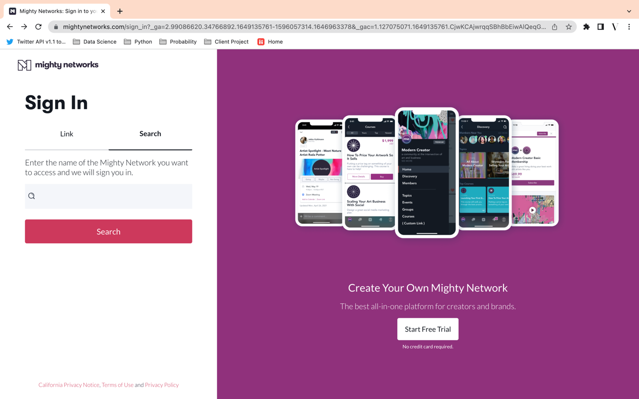

1. Type “TXACC”, see the result bar pops up, then choose “TXACC: Resource Center”

NOTE: The correct name has the “:”

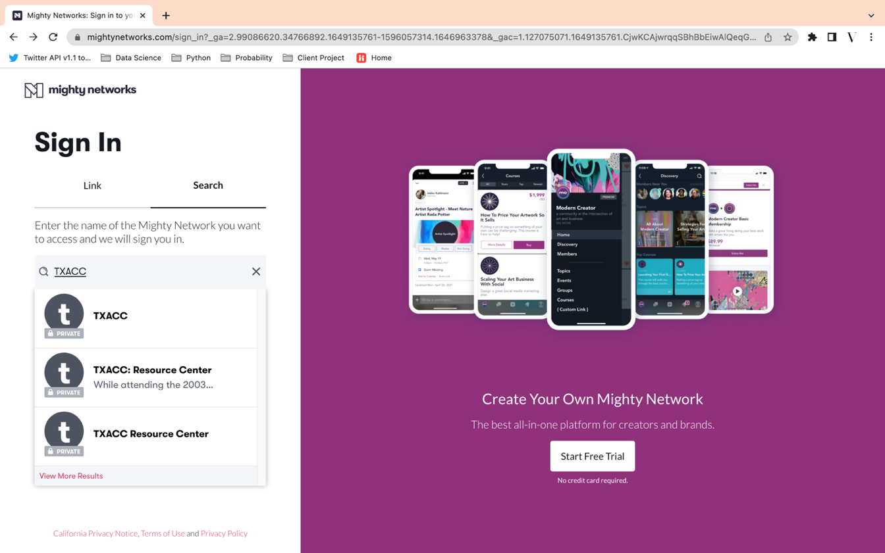

1. Click on **Request Access** on the top-right corner

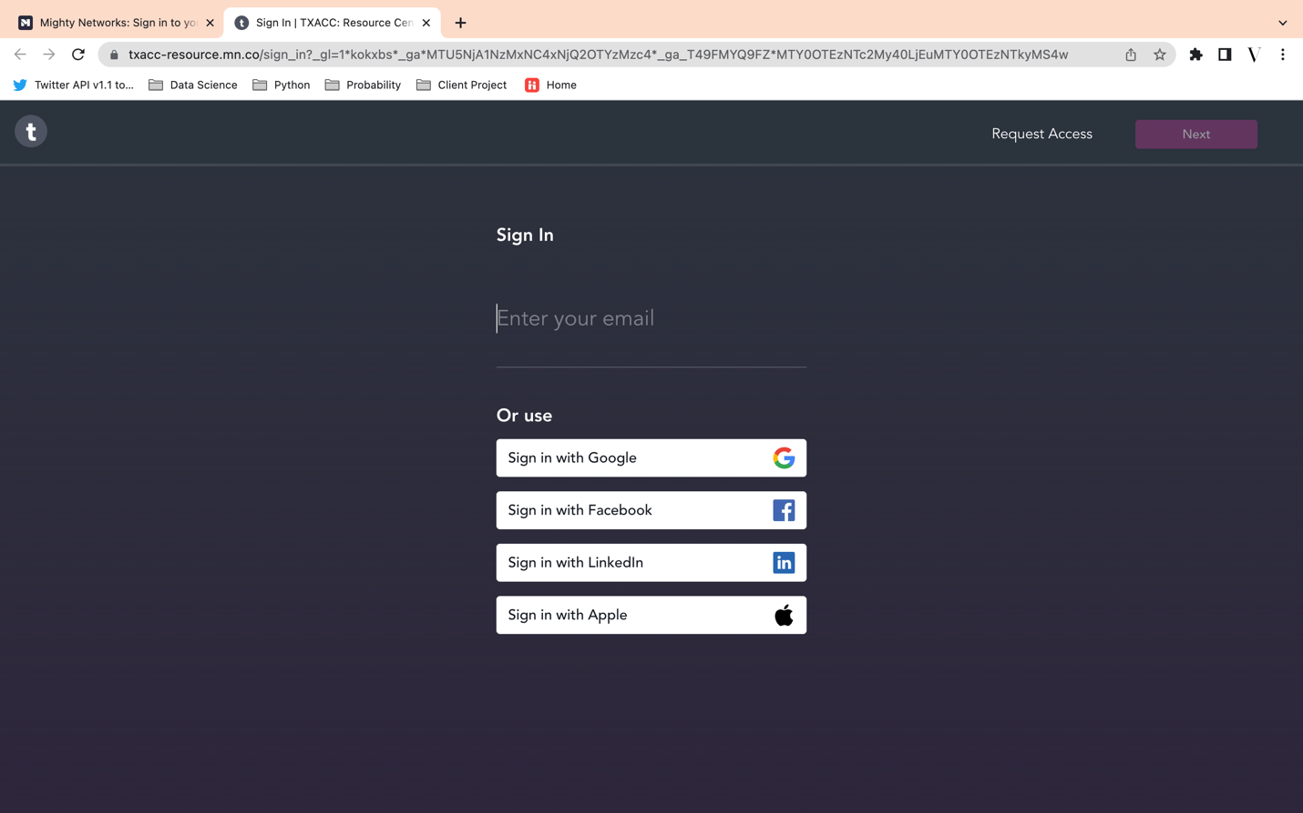

1. Type in your *First Name, Last Name* (Required), and add an *avatar* of yourself (Optional), then hit **Next** on the top-right corner

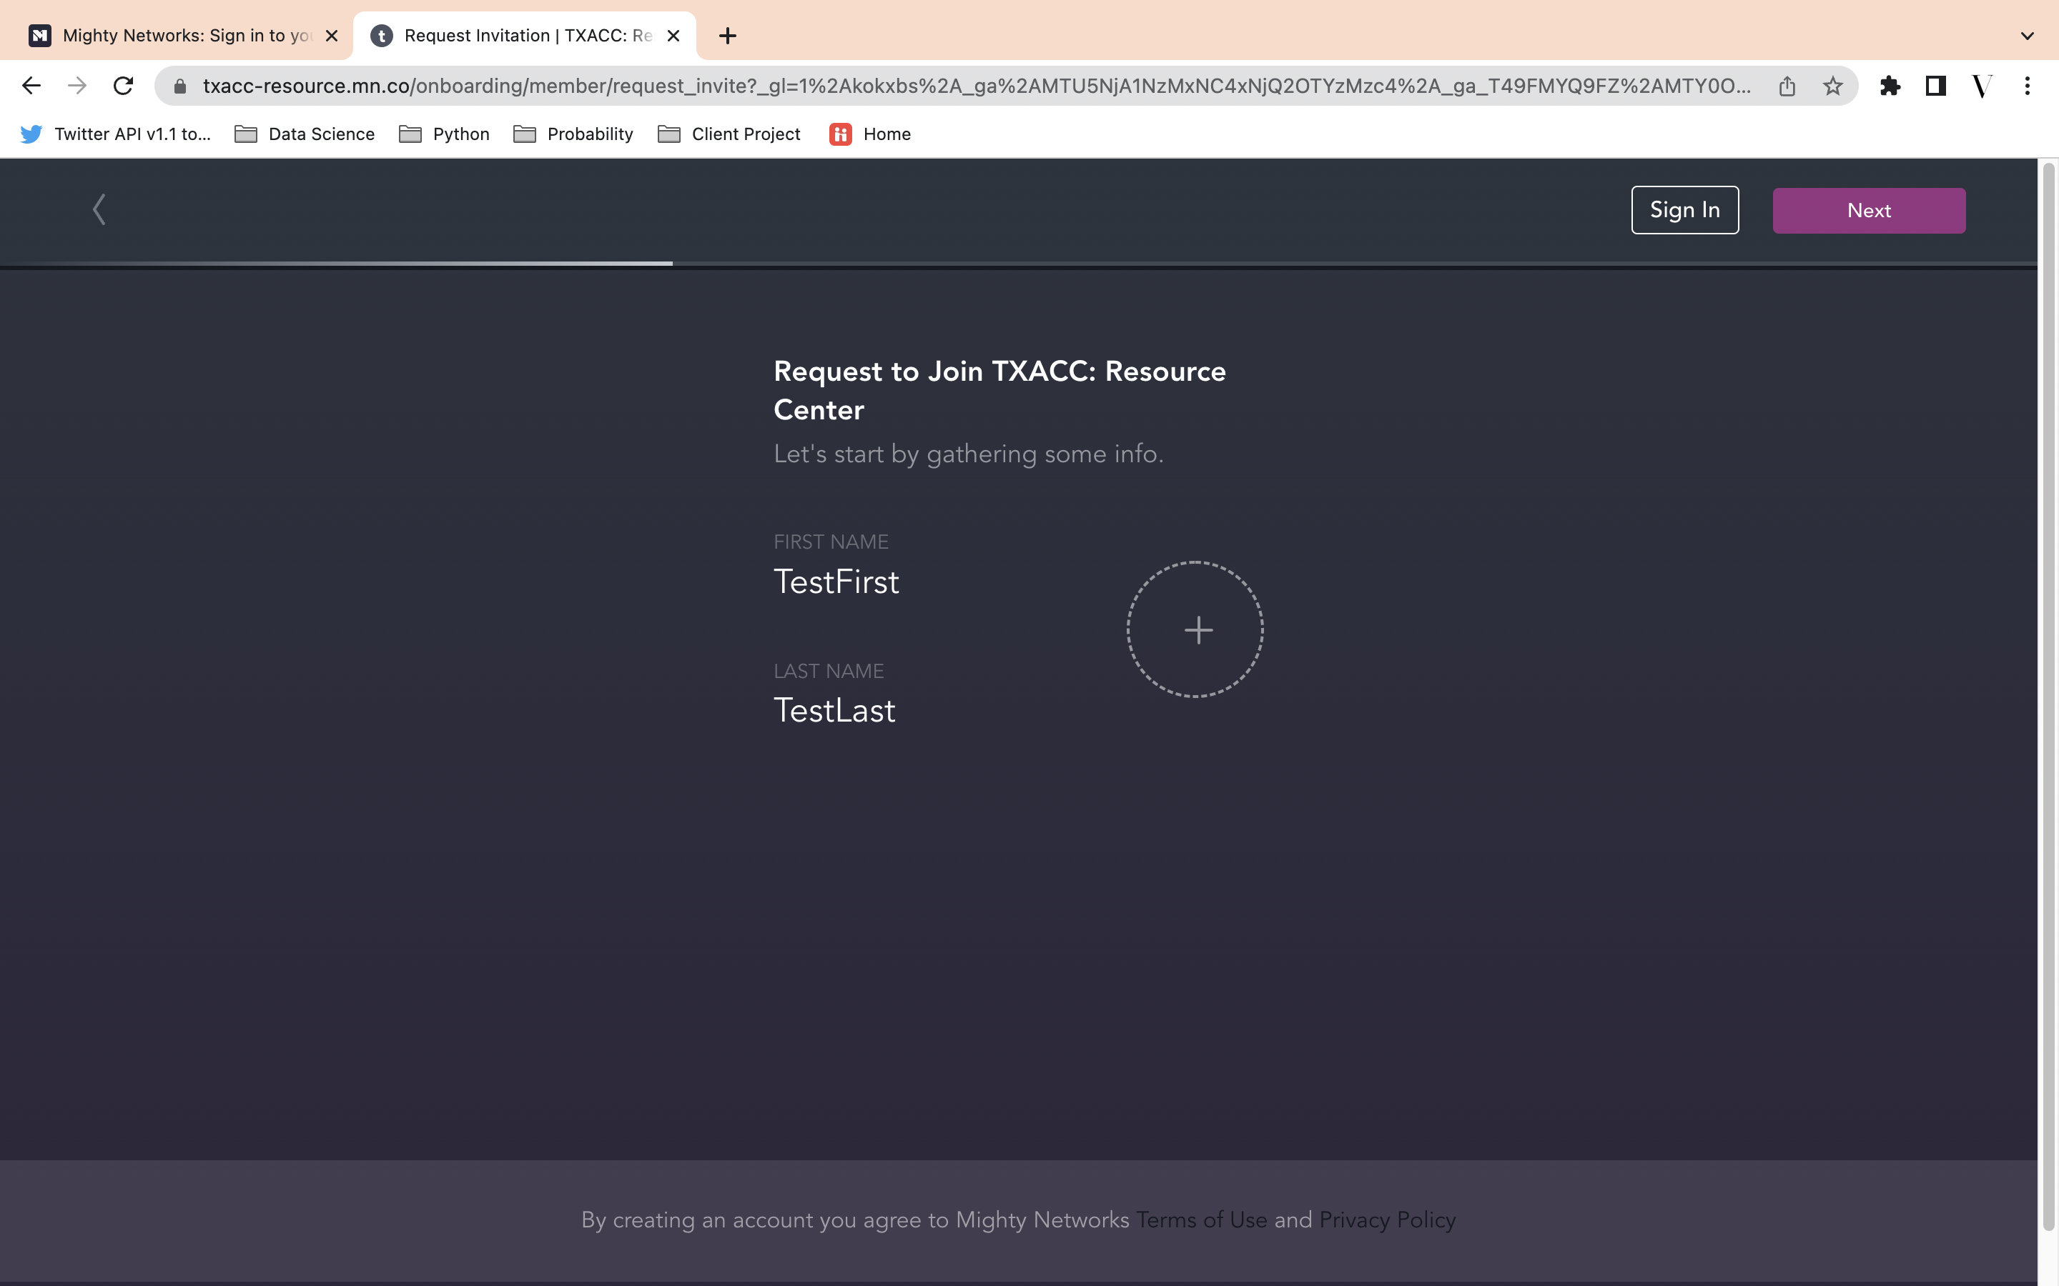

1. Type in your organization email address, then hit **Next** on the top-right corner

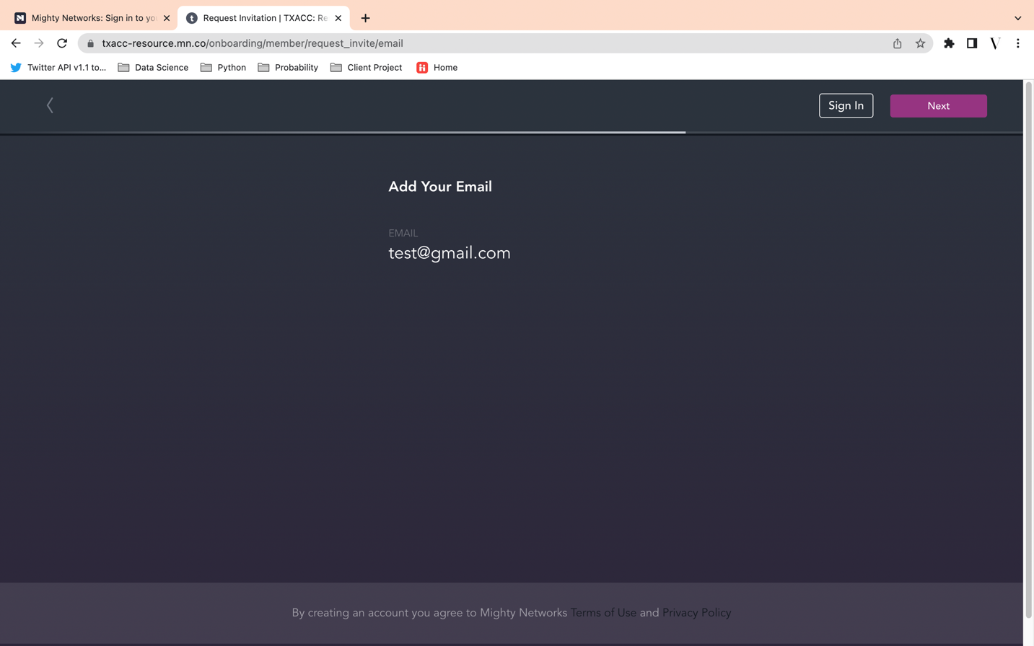

1. Type the brief reason why you want to join the group, then click **Submit** on the top-right corner

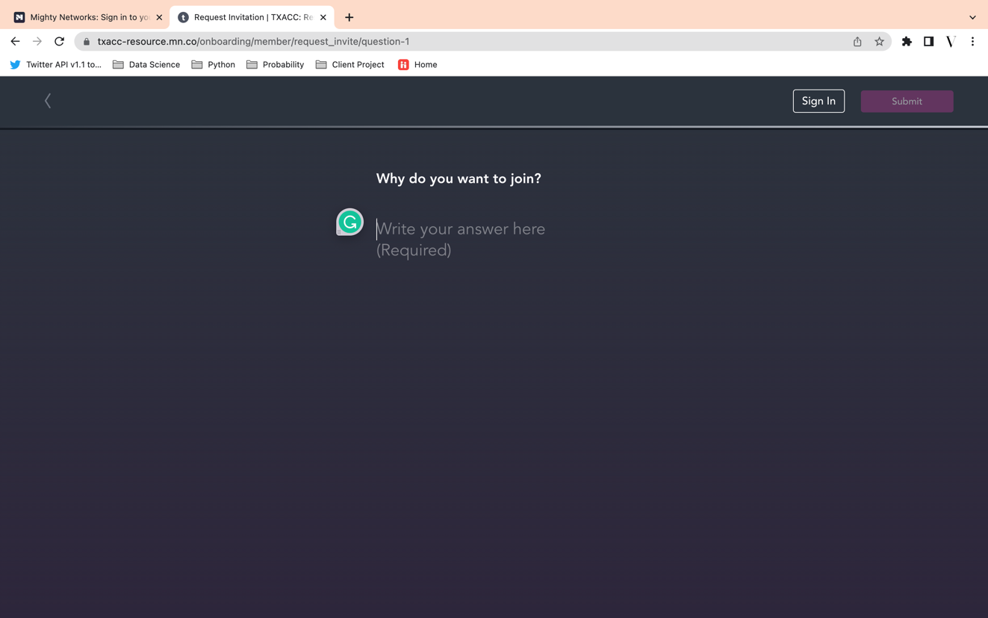

1. You will be navigated to this confirmation page. Now, just wait till the admin accept your request

NOTE: Waiting time will be varied. However, if you have not heard back for more than 48 hours, please contact [umera@texasacc.org](mailto:umera@texasacc.org)

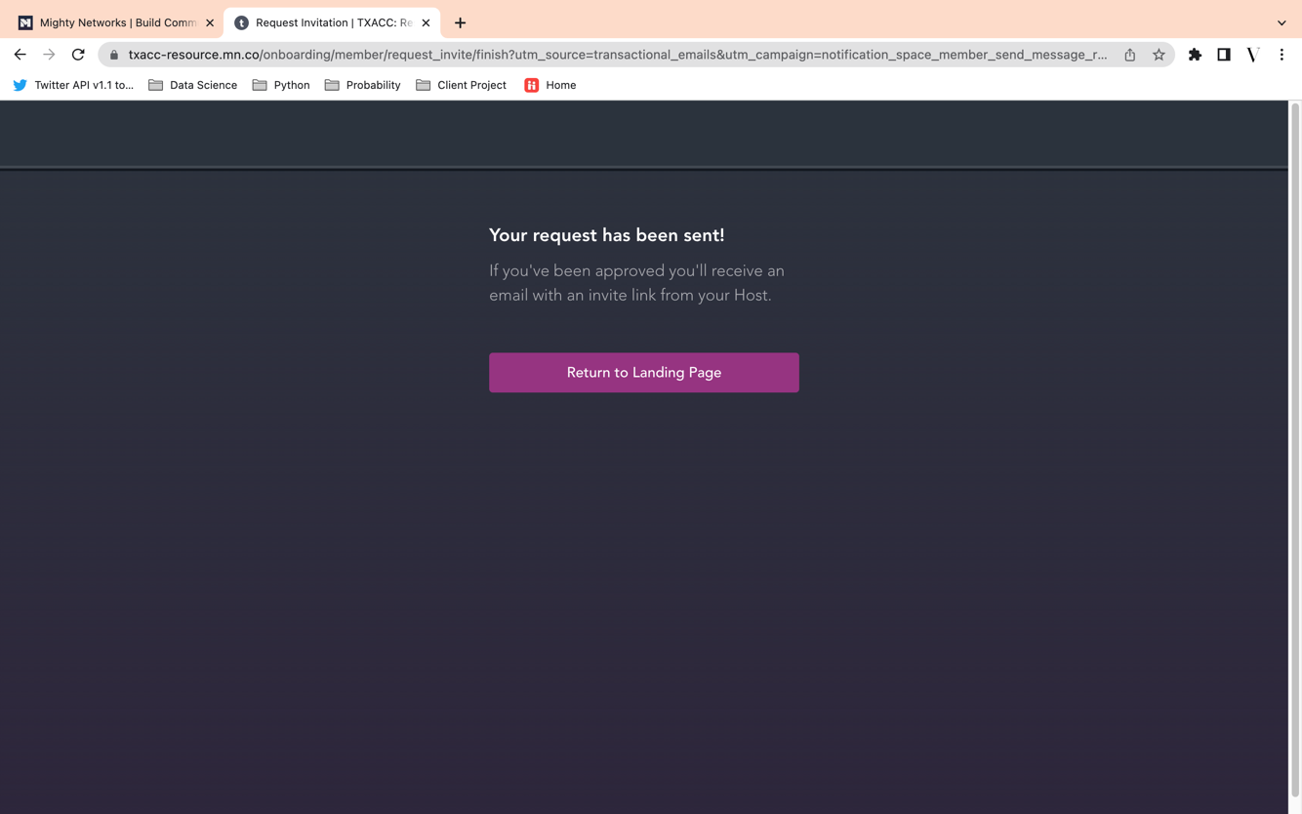

1. Check your mailbox for the invitation link. Click on the button/link in the email to join.

NOTE: Remember to search through the Primary inbox, Promotion inbox, and Spam.

The email will be sent by the admin who admitted you to the Resource Center (the name of the admin is subject to change). It is best to look for the email from [txacc-resource@mn.co](mailto:txacc-resource@mn.co)

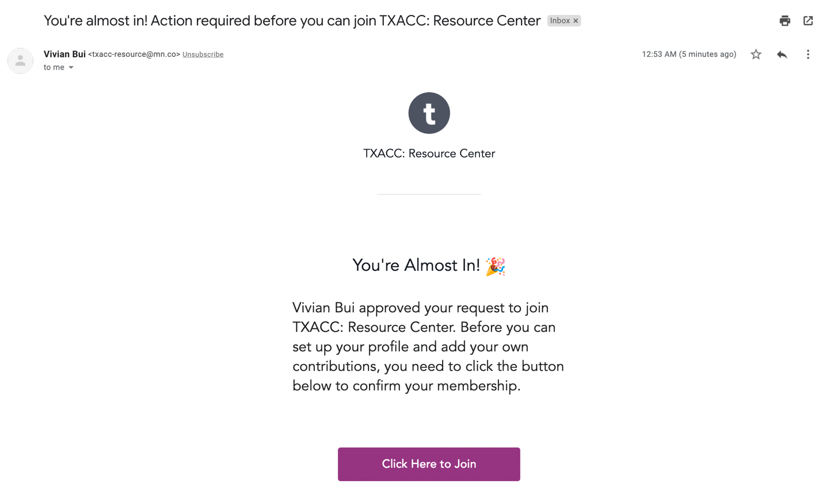

How to register a new account – with an Invitation

1. Navigate to your mailbox and look for the email with the invitation. Then click on **Join Me**.

NOTE: The name of the person who sent you the invitation is subject to change.

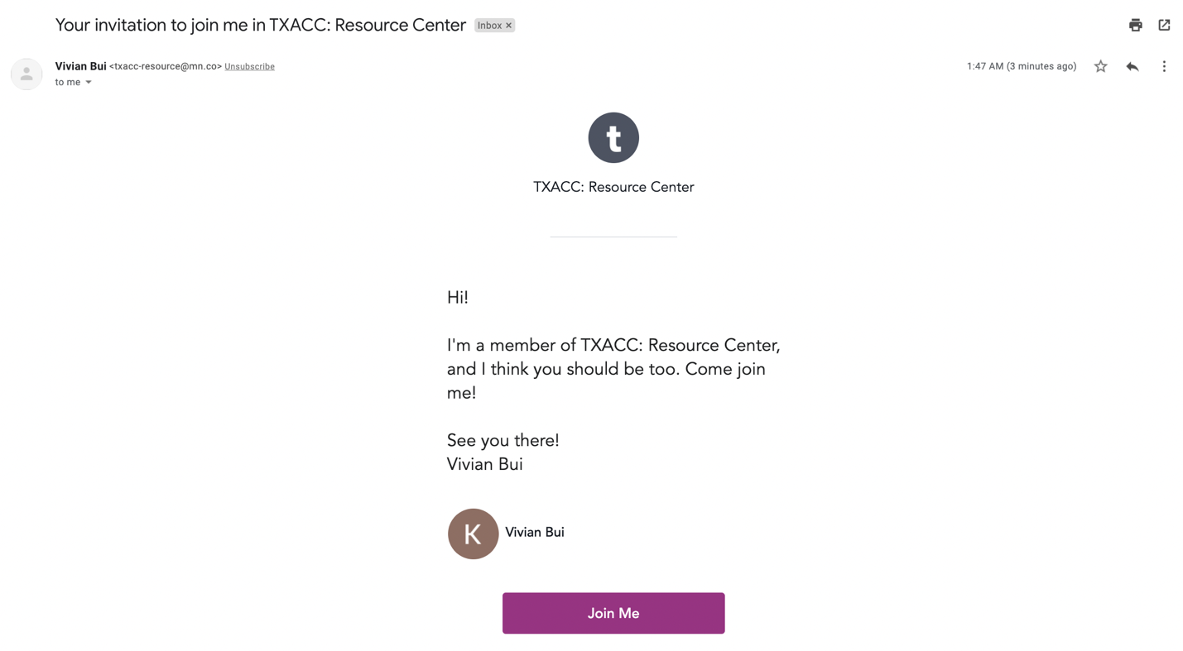

1. You will be then redirected to the homepage of the Resource Center.

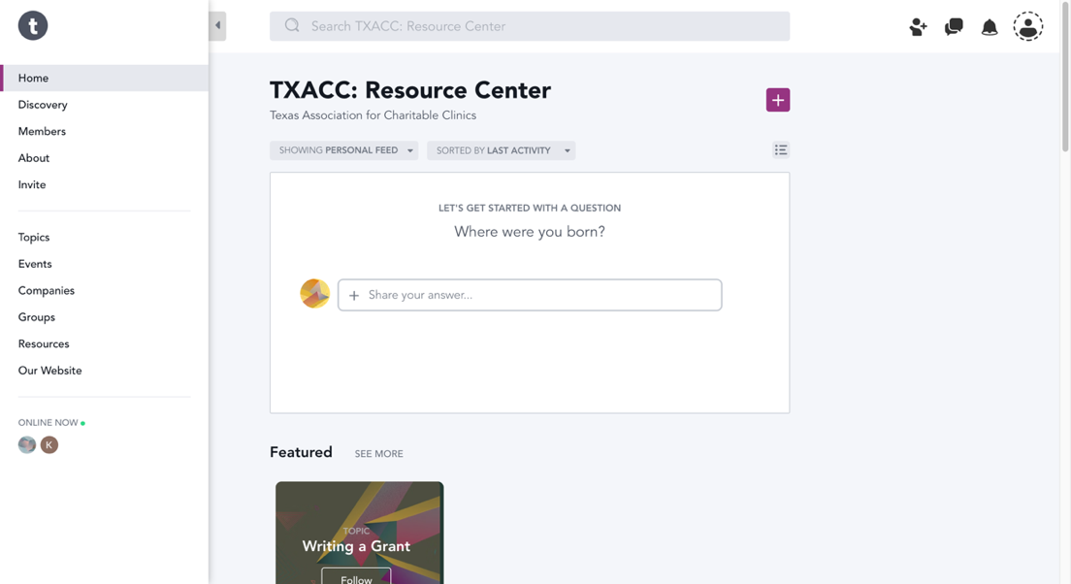

How to login – from Mighty Network homepage

1. Navigate to the [Mighty Network homepage](https://www.mightynetworks.com/)
2. Click on the **Sign In** button on the top-right

NOTE: the Homepage photo may look different on your end. Still, navigate to the **Sign In** button on the page



1. Click on **Search**



1. Type “TXACC”, see the result bar pops up, then choose “TXACC: Resource Center”

NOTE: The correct name has the “:”

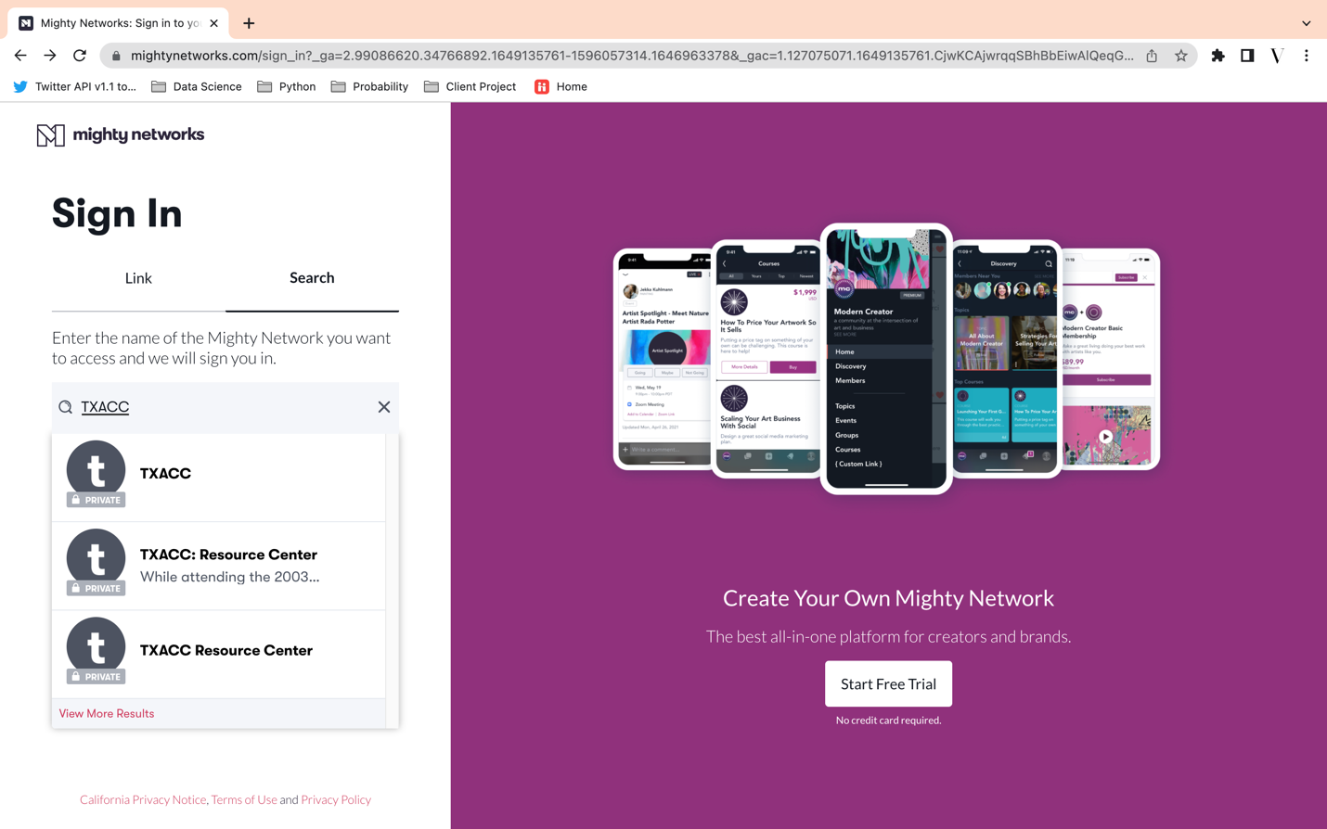

1. Type in your registered email, or use other sign-in options that you registered with



1. OPTIONAL: If you type in your email (meaning that you did not sign in through Google, Facebook, LinkedIn, or Apple account), the system will email you a magic link to log in. Open the email > Click on **Sign In**.

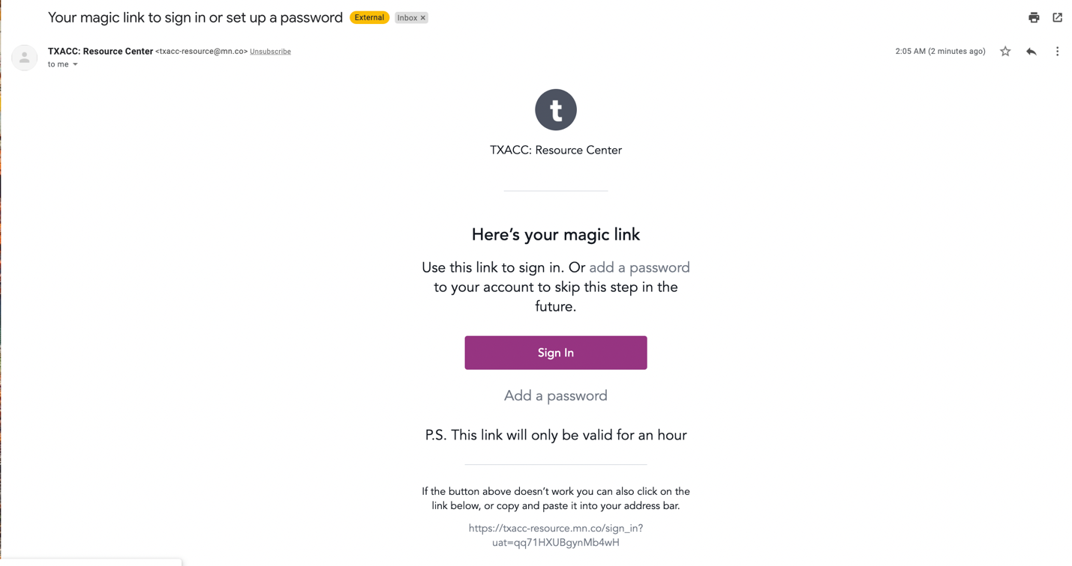

1. By clicking on the button in the email, you will be automatically redirected to the Resource Center

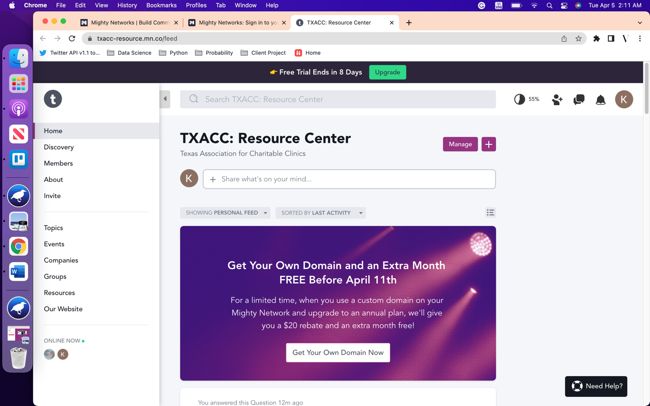

How to login – using the Invitation link

1. Navigate to your mailbox and look for the email with the invitation. Then click on **Join Me**.

NOTE: The name of the person who sent you the invitation is subject to change.



1. You will be then directed to the following page. Click on **Sign In** on the top-right corner 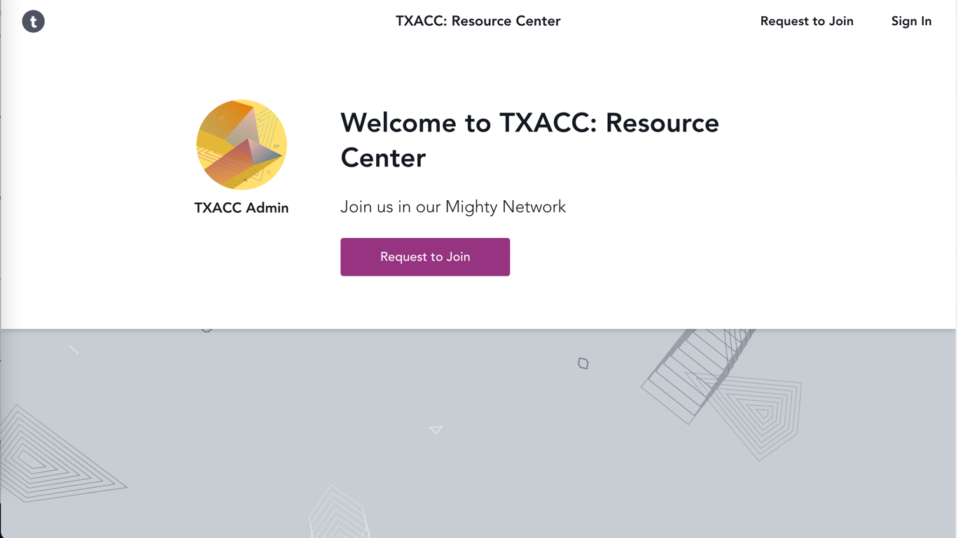
2. You will be then directed to the following page. Follow instructions in Part I – Step 5 to Step 7.

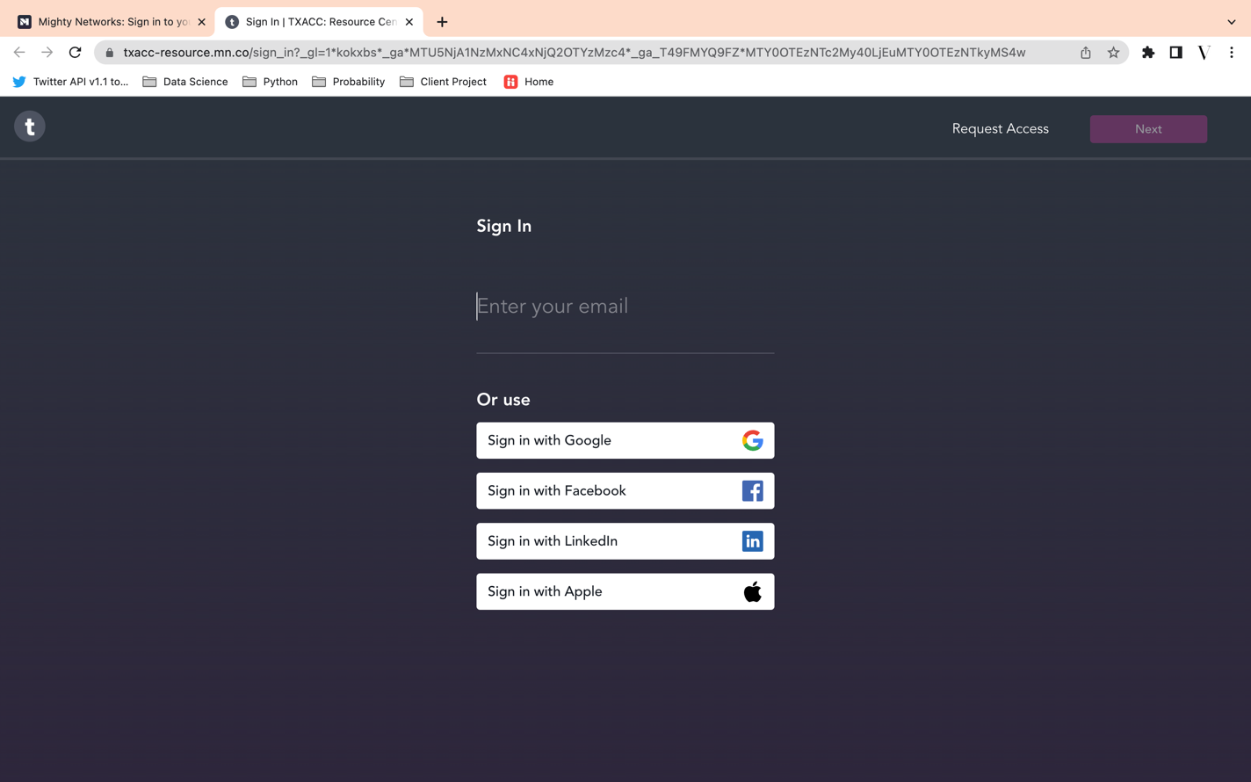

How to login – by going to the Resource Center link (Highly Recommended)

1. Navigate to the following link: <https://txacc-resource.mn.co/>
2. You will see the following page. Click on **Sign In**.

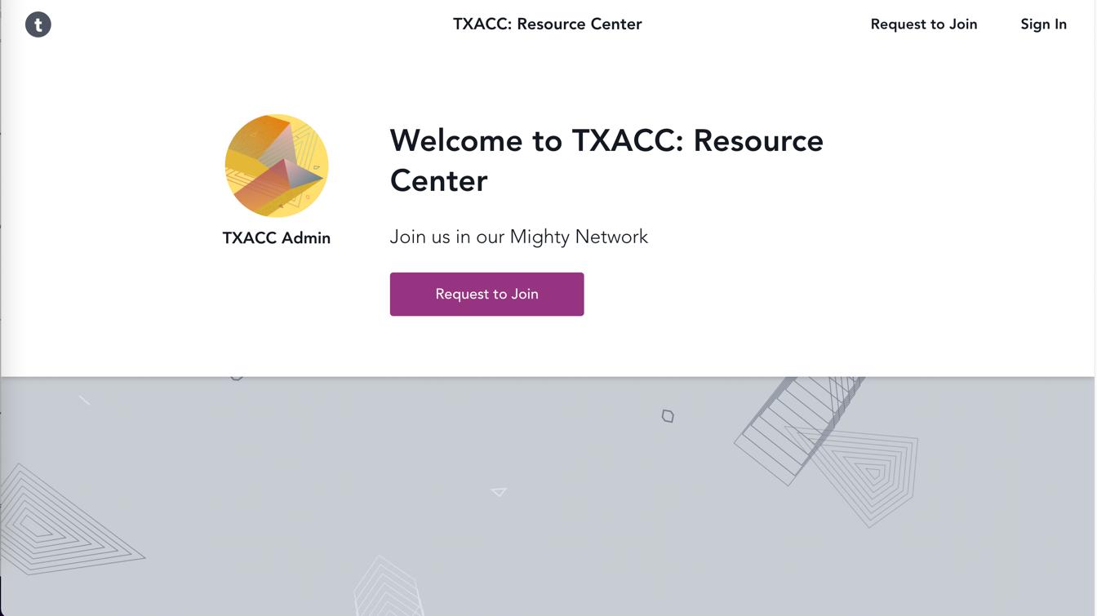

1. You will be then directed to the following page. Follow instructions in Part I – Step 5 to Step 7.

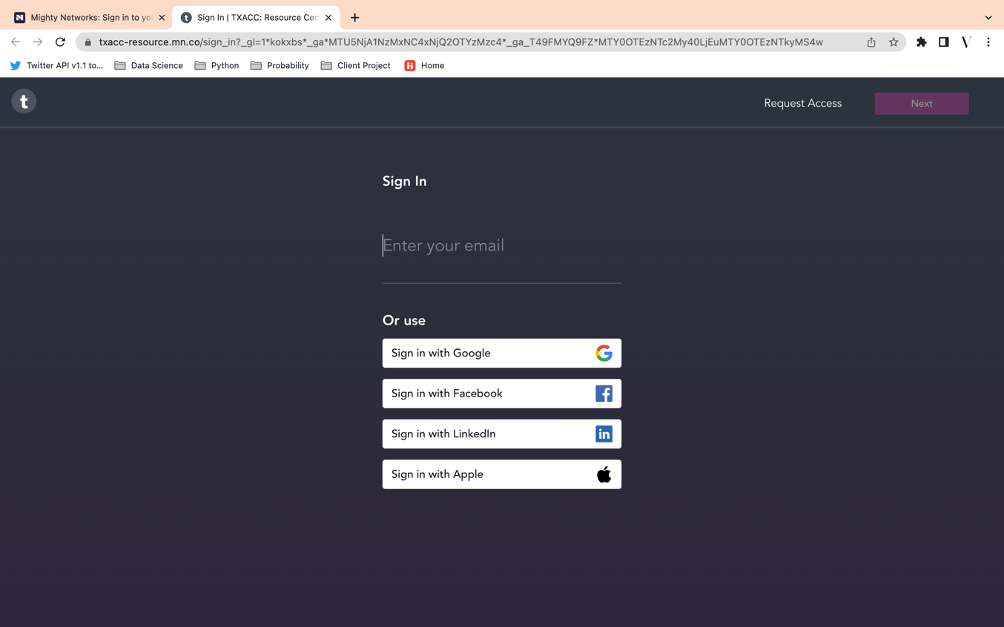

What information of my profile will be visible to other users?

Other users can see your:

* First name (Required)
* Last name (Required)
* City (Required)
* Personal Link (Optional)
* Company (Required)
* Followers
* Groups
* Topics

What information of my profile can I edit?

You can edit your:

* First name
* Last name
* About You
* Location (City and State)
* Company
* Personal Links
* Introduction
* Timezone
* Resources*
* Groups*
* Topics*

(*) Editing these sections will only change the visibility of these information on your profile. This does not change your actual participation in the Resources, Groups, or Topics.

How to view/edit your profile

1. After logging in, navigate to the top-right corner of the page

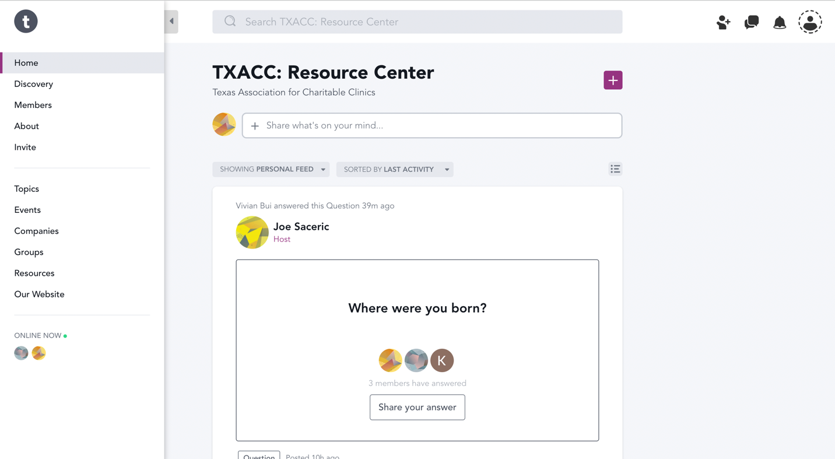

1. Click on **View your Profile**

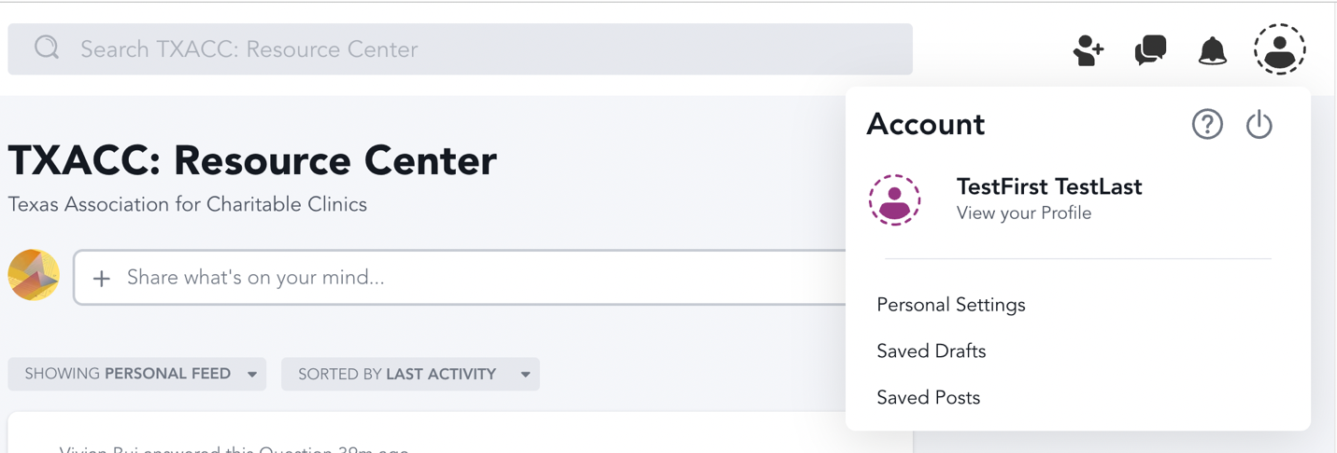

1. A window will pop up from the right handside that shows your profile. You can view all the information about you and decide to make update by clicking on the  sign at each of the section or type in the textbox.

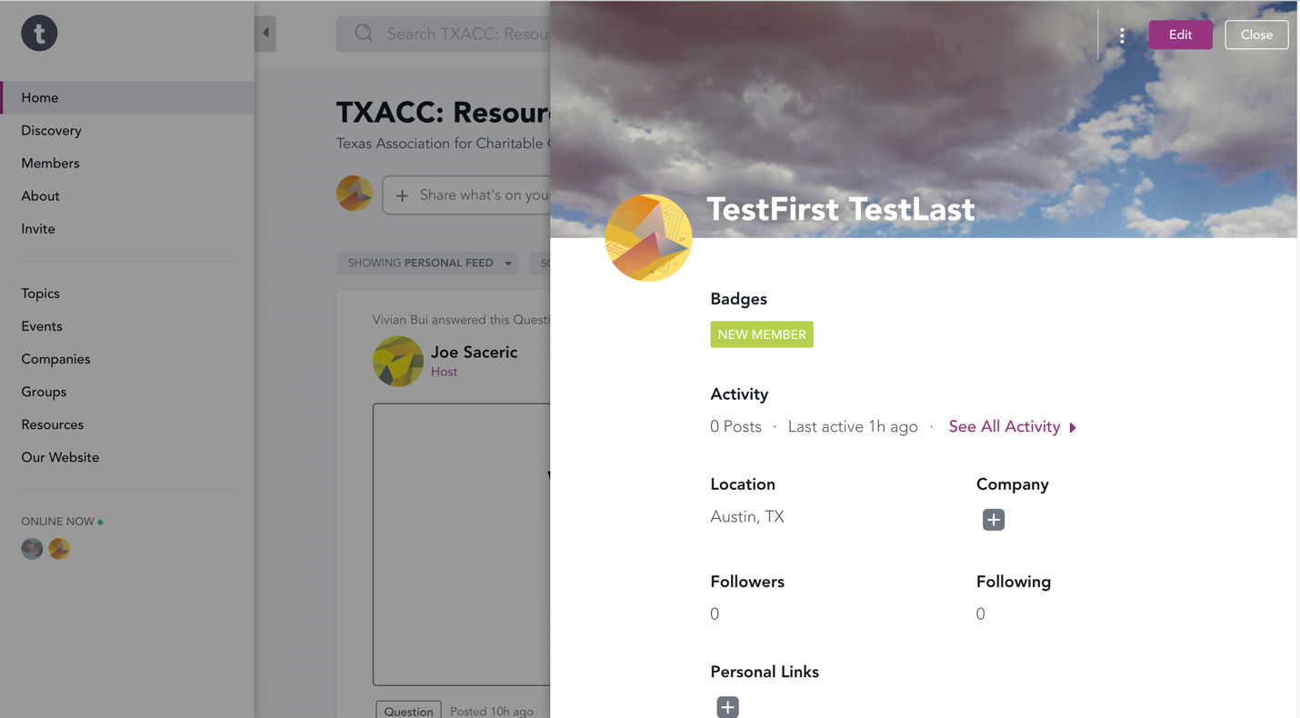

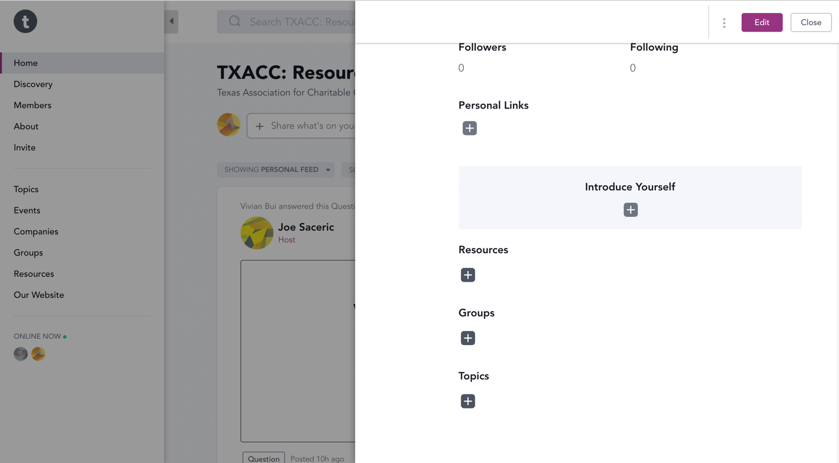

1. OPTIONAL: You can also edit your profile by:
2. Click on the Edit button, then type in the textbox or click on the  for each section you want to edit.

Or (2) Click on Personal Settings > Edit Profile > Type in the text box or click on the  for each section you want to edit.



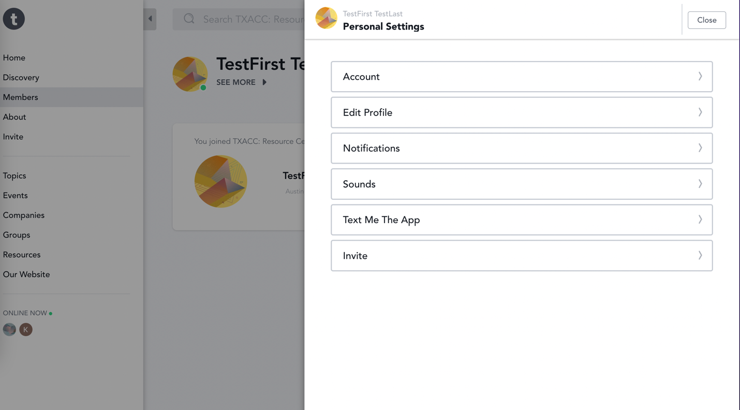

How to upload files

1. After logging in to Mighty Network, navigate to “Resource” on the menu bar on the left-hand side.

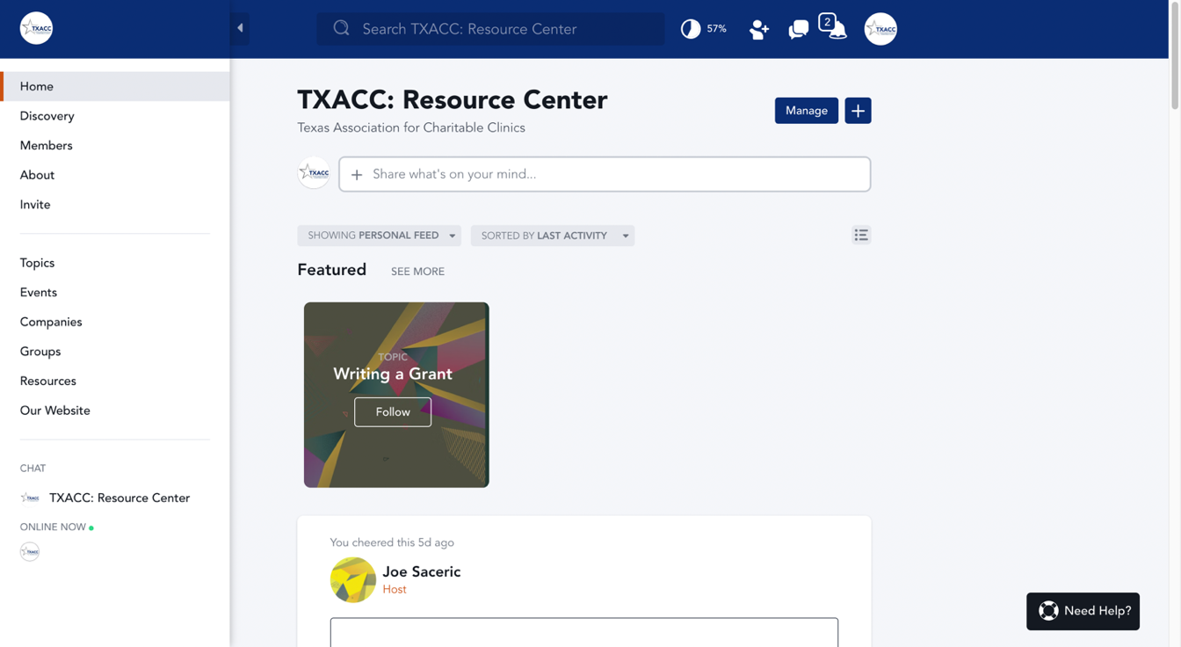

1. Click on the Resource you want to upload the file.

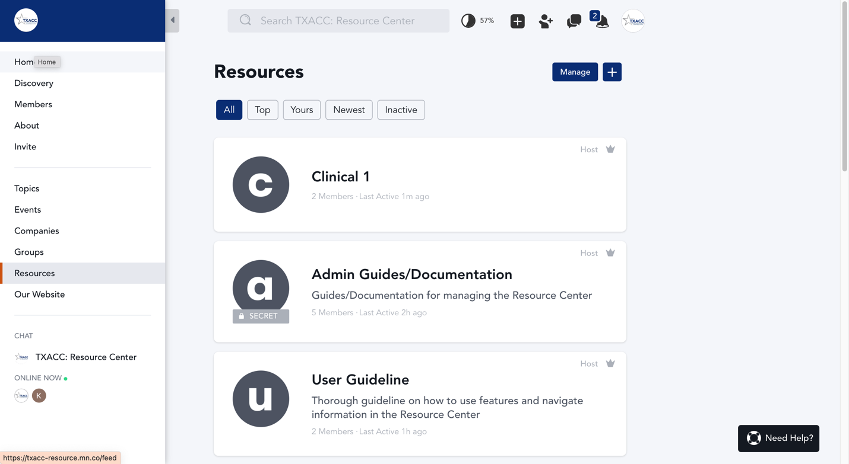

1. Next, navigate to the CHAT section.

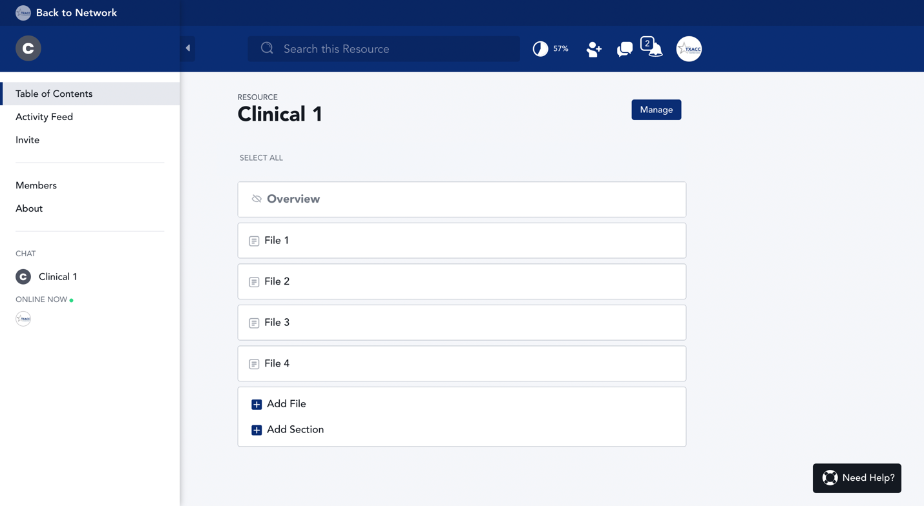

1. Click on the Plus sign next to the Chat bar.

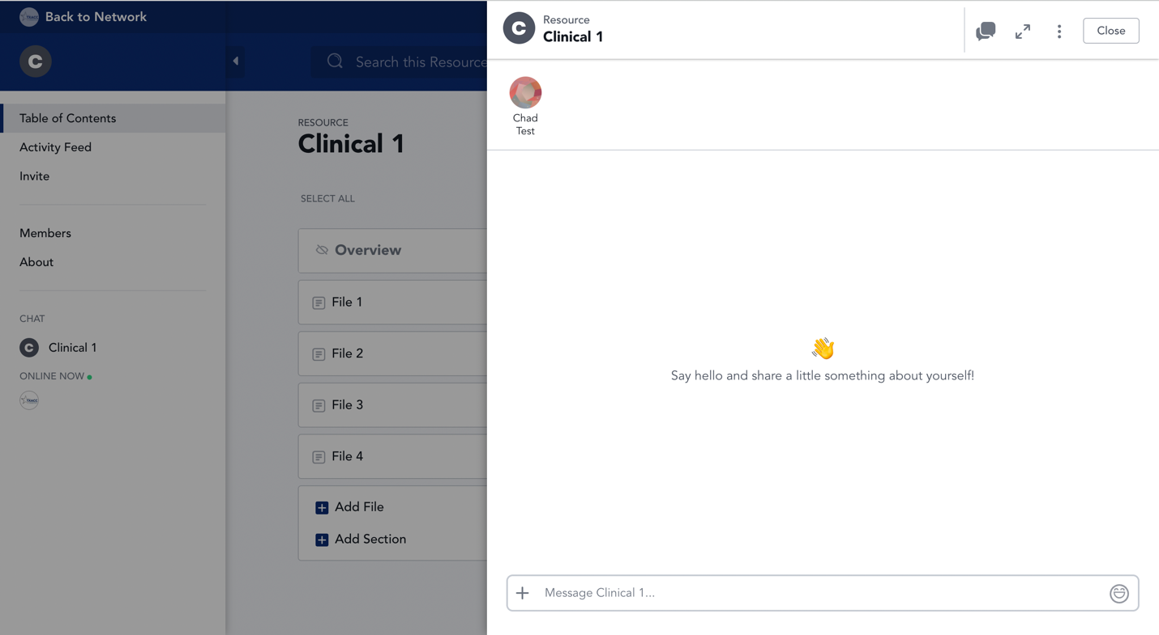

1. Choose “Attach File”.

NOTE: Either you want to upload a file or photo, we recommend choosing “Attach File” regardless. It is because “Attach File” also allows you to upload photos while choosing “Add Photos” will limit you to upload photos only.

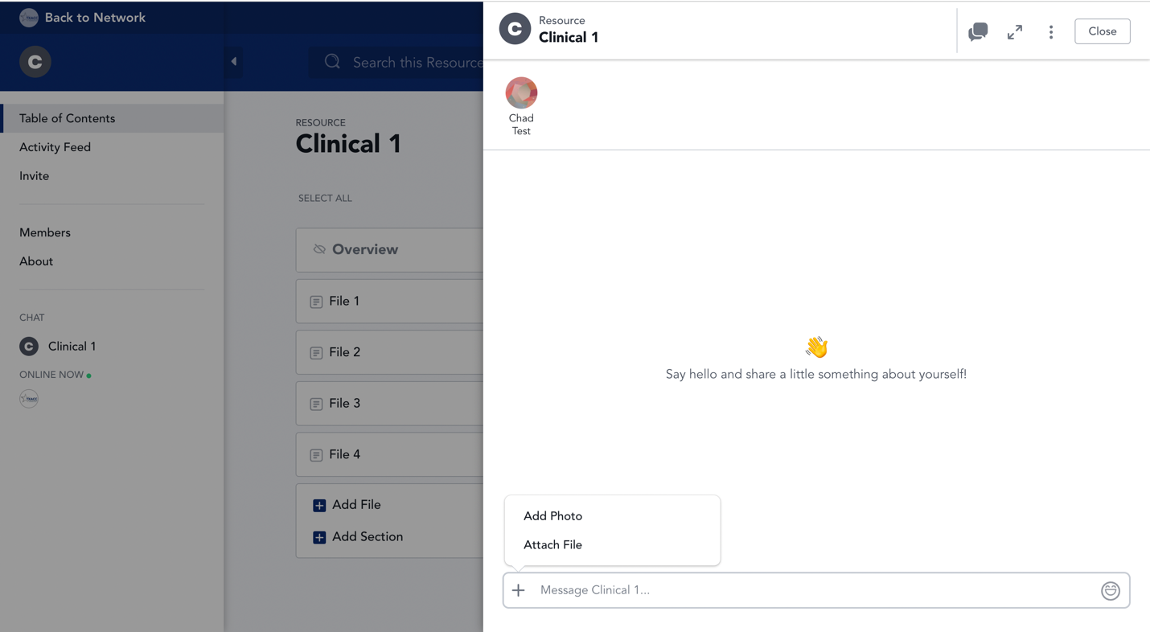

1. Next, select the file you want to upload. Then, click “Open”.

NOTE: This screen may look different if you are a Windows user. If you are a Windows user, there will still be a similar screen pops up that allows you to select the file you want to upload.

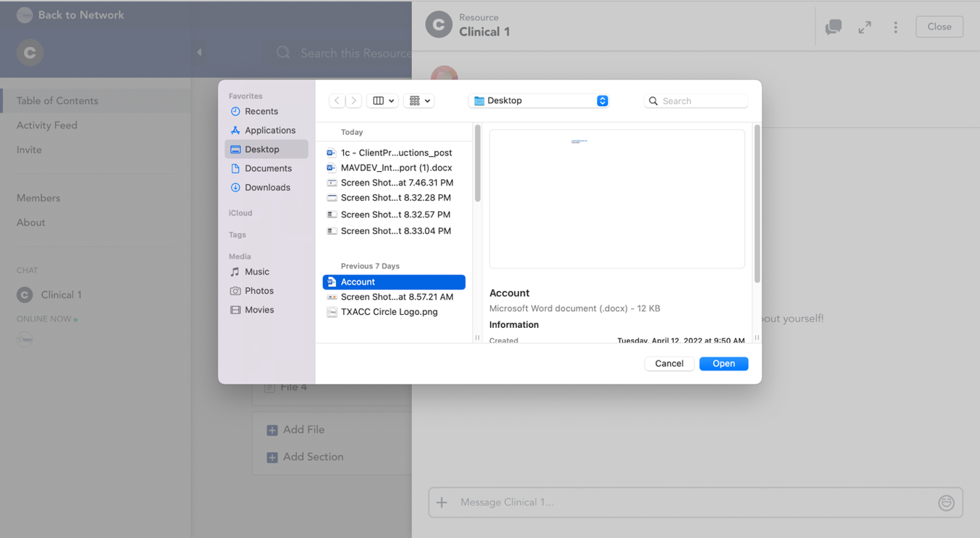

1. You now can see the file has been uploaded to the resource.

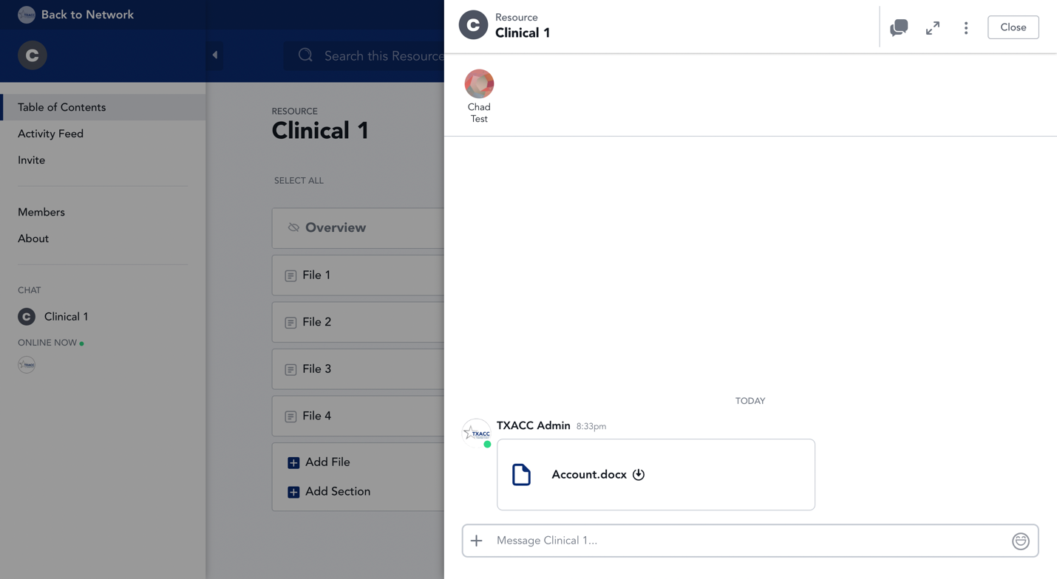

How to join a group chat

1. After logging in to Mighty Network, navigate to “Group” on the menu bar on the left-hand side.

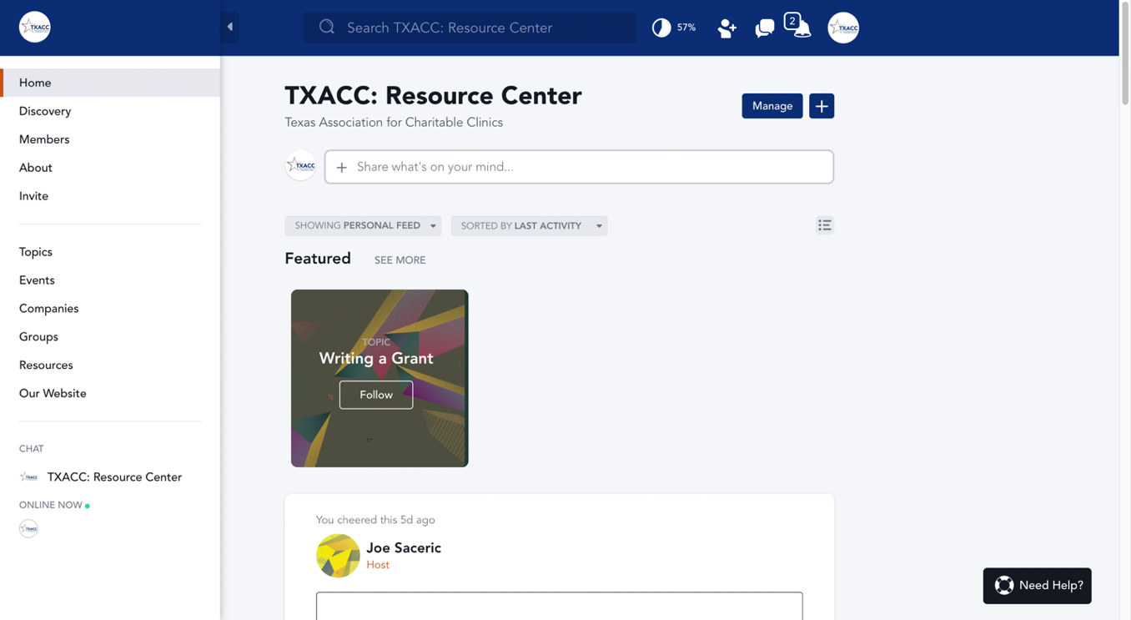

1. Click on the group you want to create/join a chat.

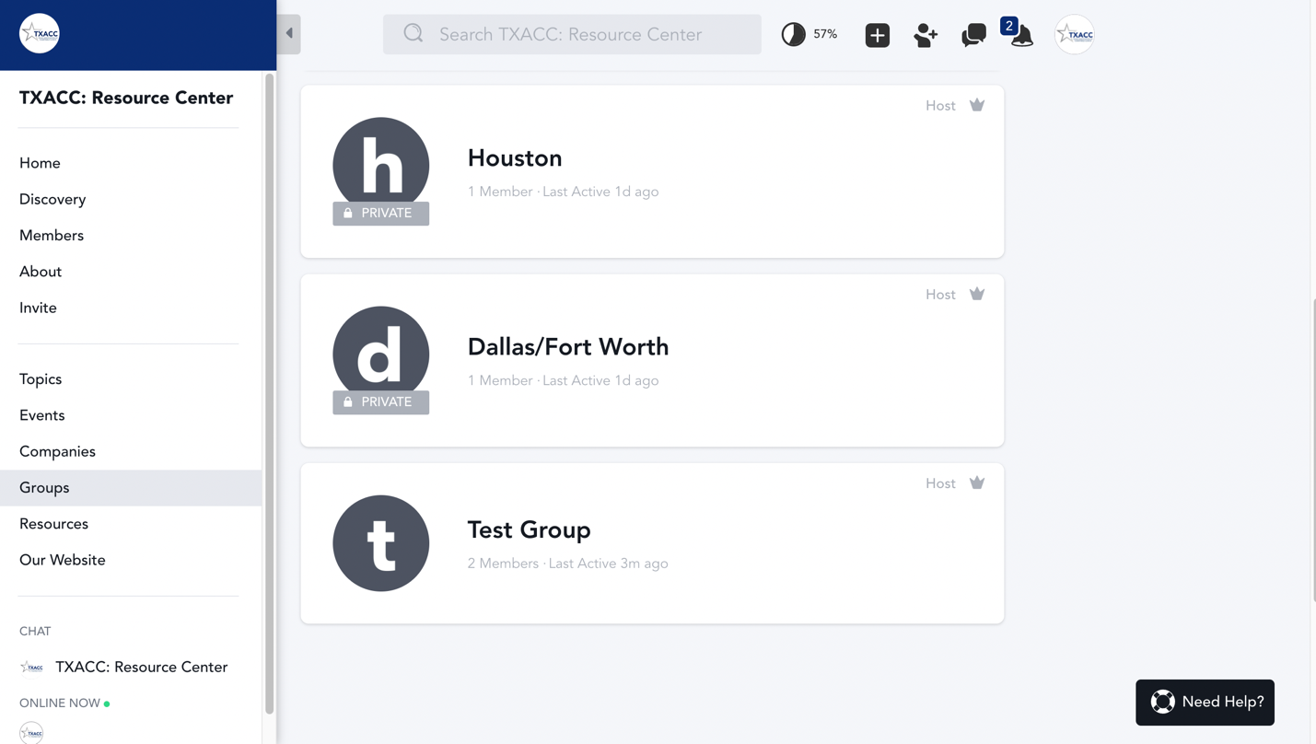

1. Once getting in the group, navigate to the Chat on the menu bar at the left side.

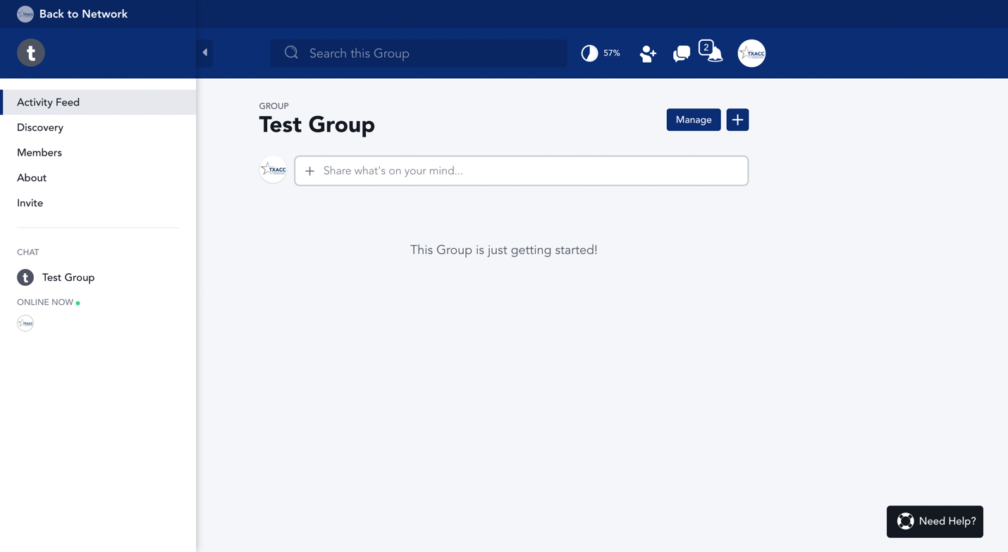

1. You are now in the group chat.

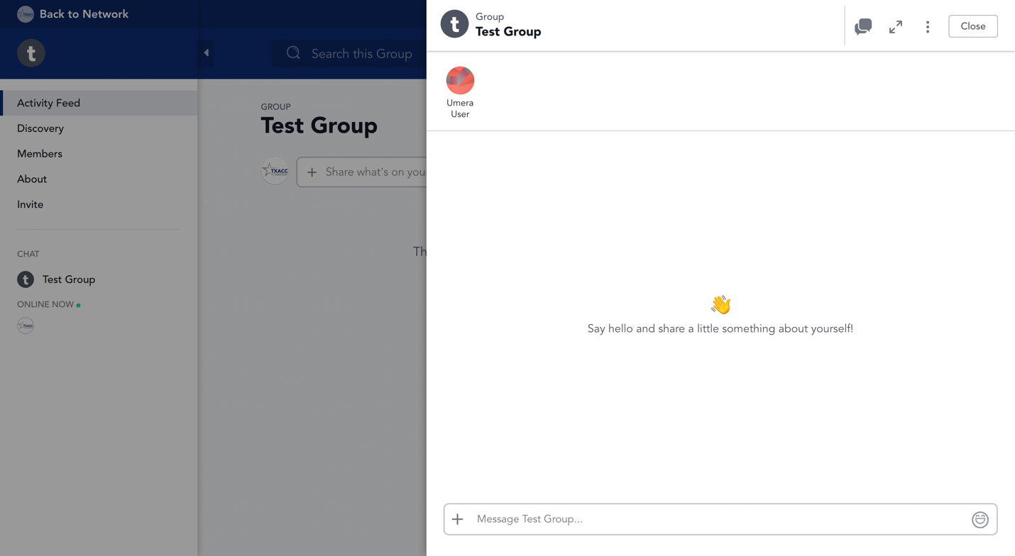

How to join a group chat – from Direct Message

1. After logging in to Mighty Network, navigate to the Message icon on the top right-hand side.

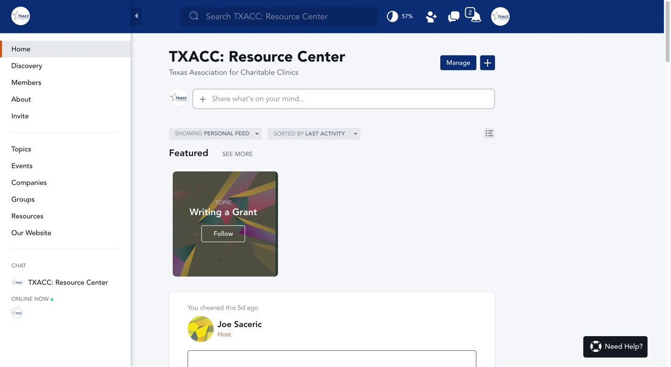

1. The list of group chats that you can join will pop up. Click on the group you want to join the conversation.

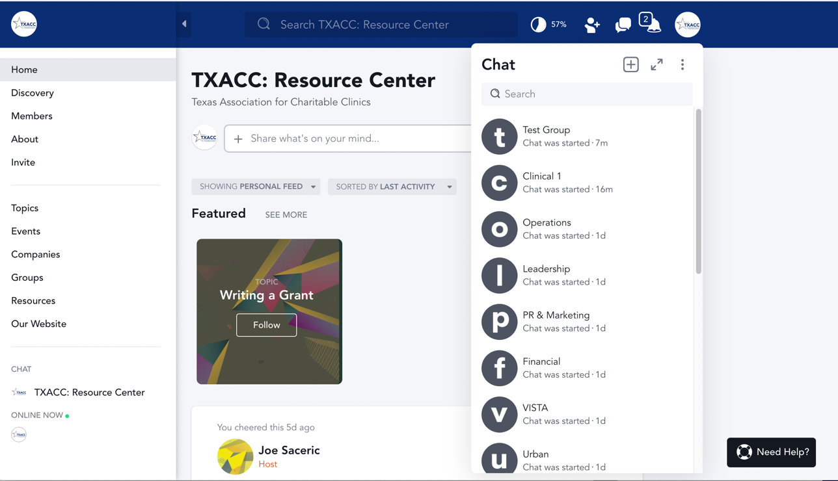

1. You are now in the group chat.

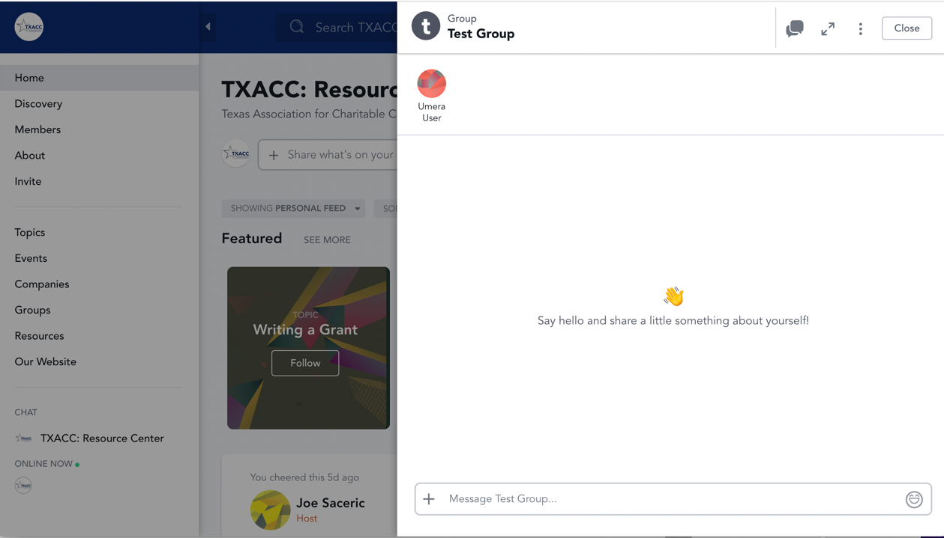

How to create a direct message

1. After logging in to Mighty Network, click on the message icon on the top right-hand-side

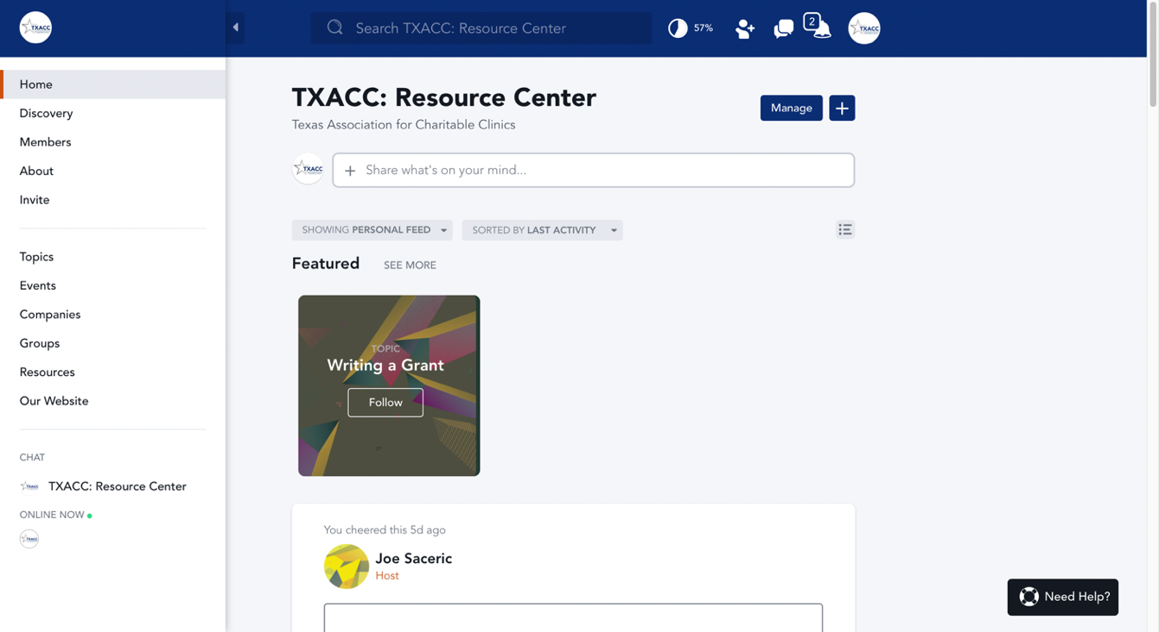

1. Next, click on the Plus sign to add a chat

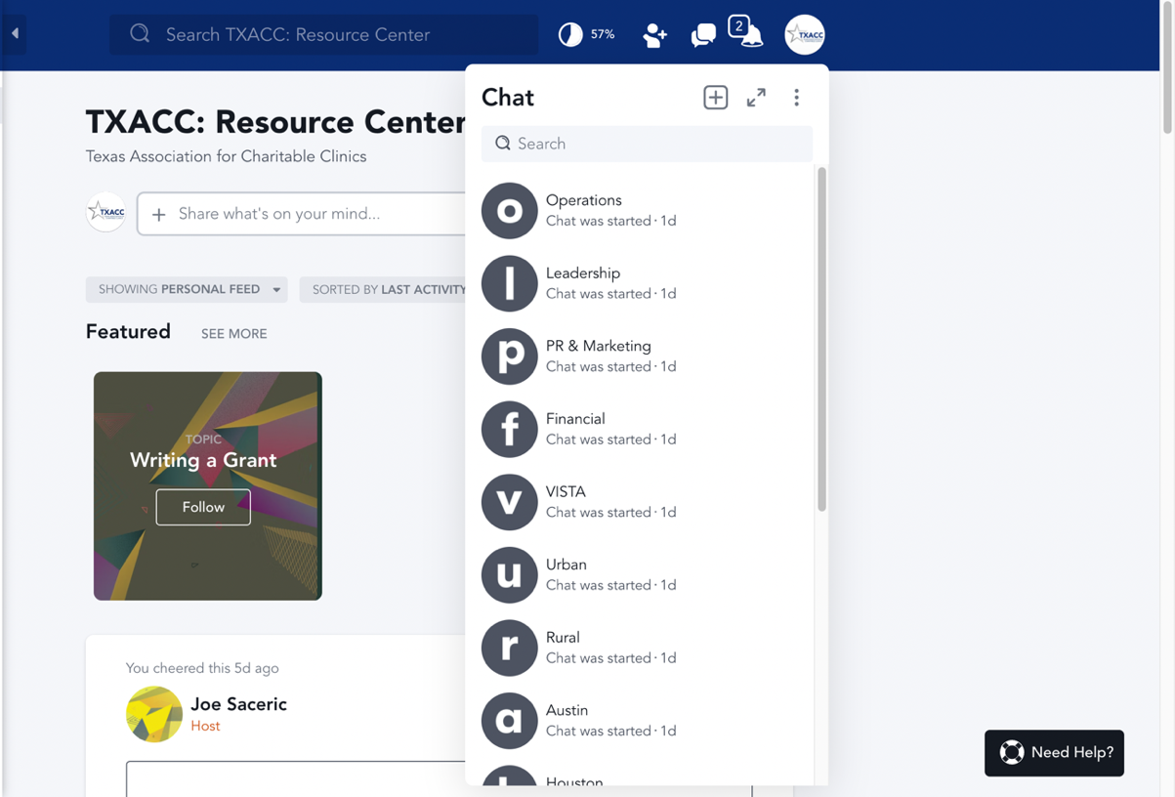

1. Next, check on the boxes for the people who you want to send direct messages

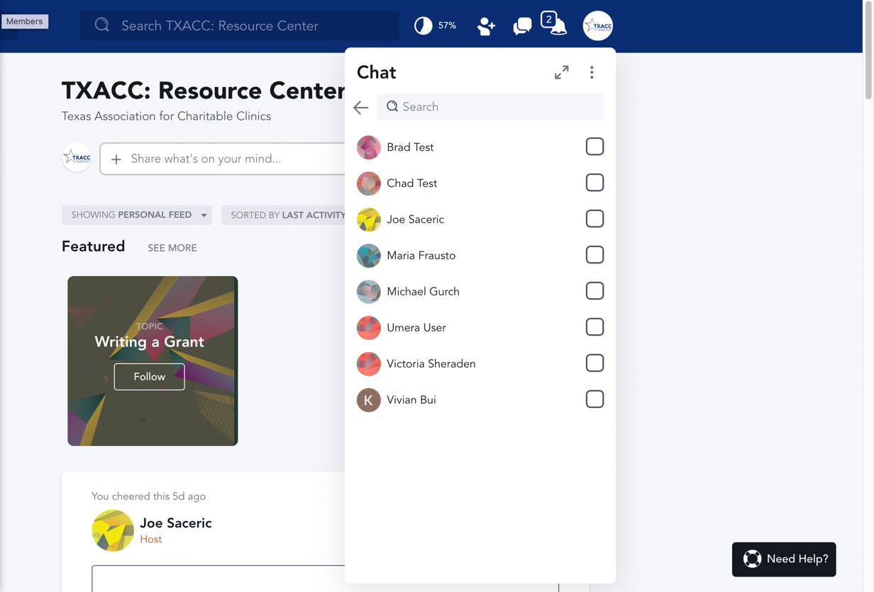

1. Next, click on “Start Chat”

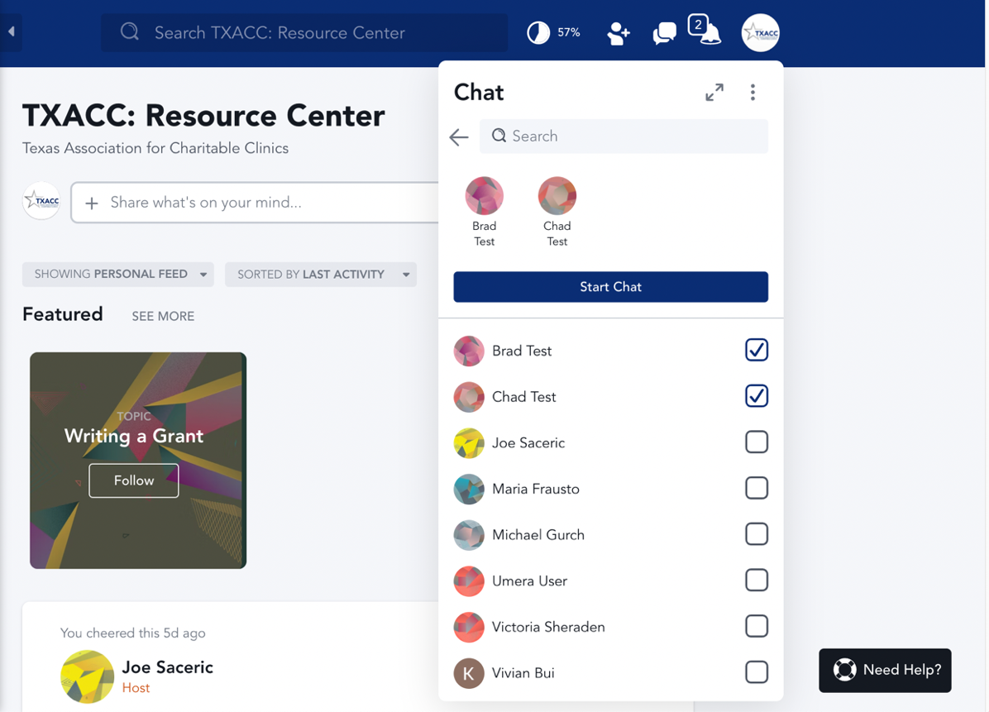

1. The direct message room is now created

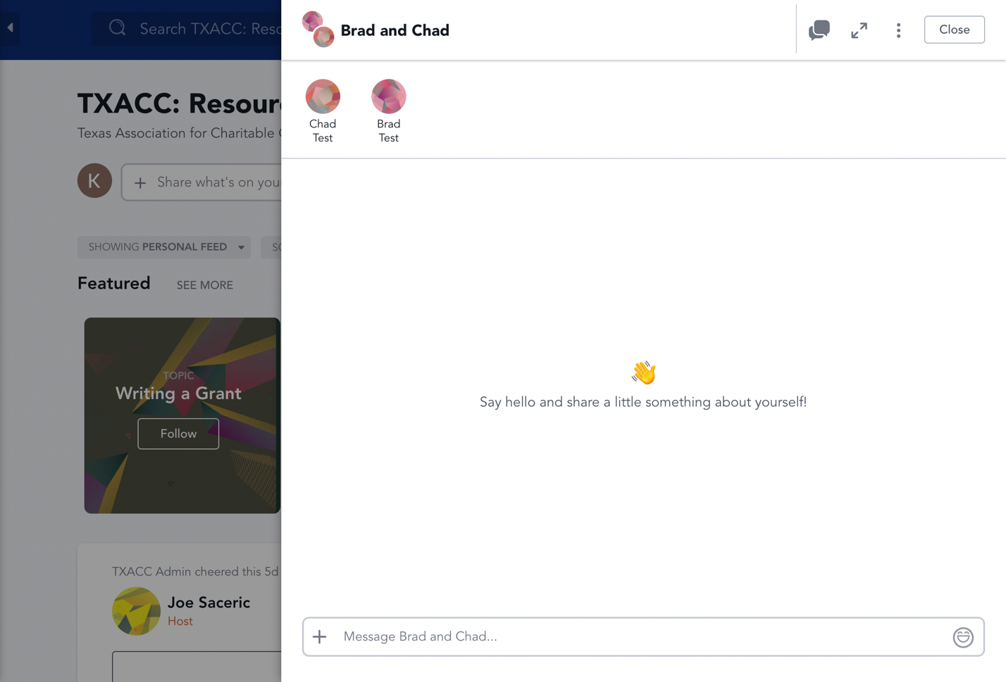

How to search for a person to direct message

1. After logging in to Mighty Network, click on the message icon on the top right-hand-side

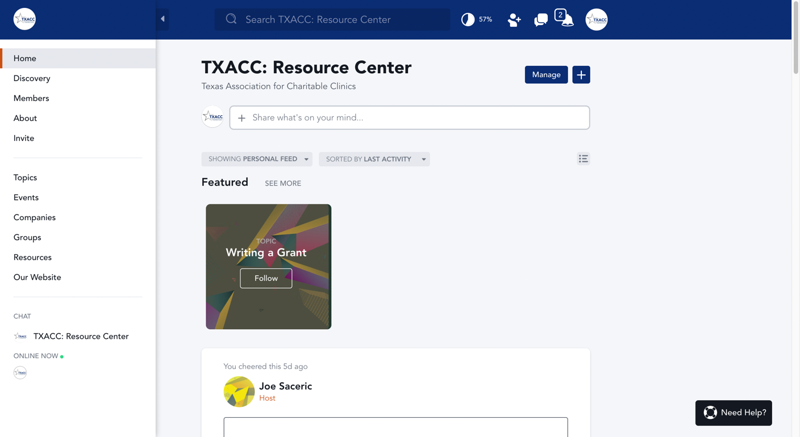

1. Next, type in the name of the person you want to send a direct message to on the search bar.

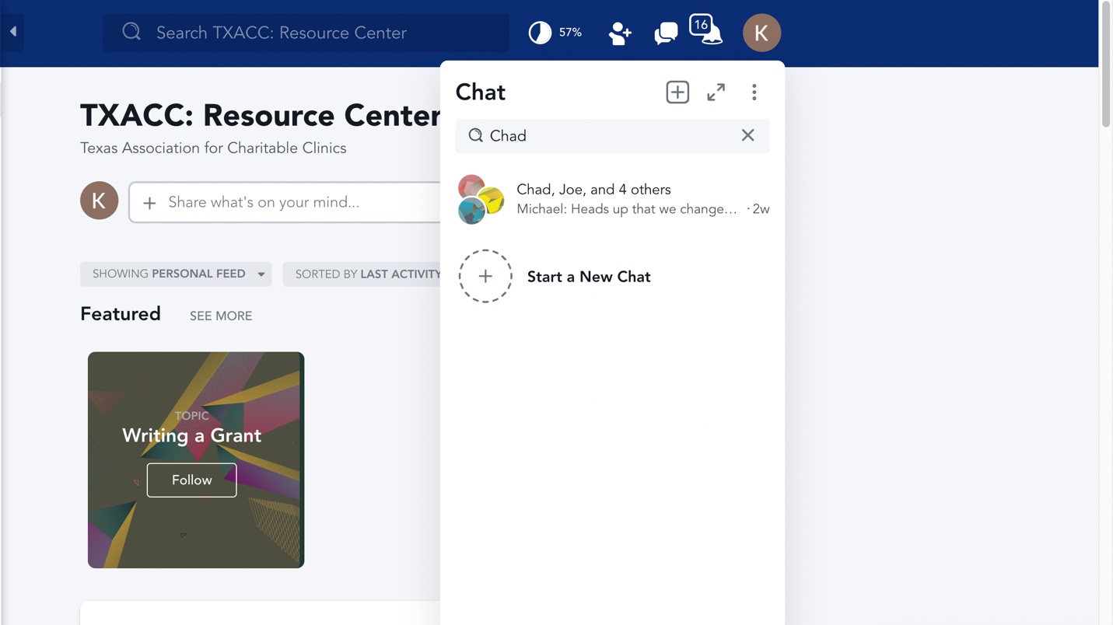

1. While typing, the name of the member will show up. Click on the checkbox next to the person’s name.

NOTE: If the name does not show up, double-check if you have the name of the member typed correctly (lowercase/uppercase does not matter!)

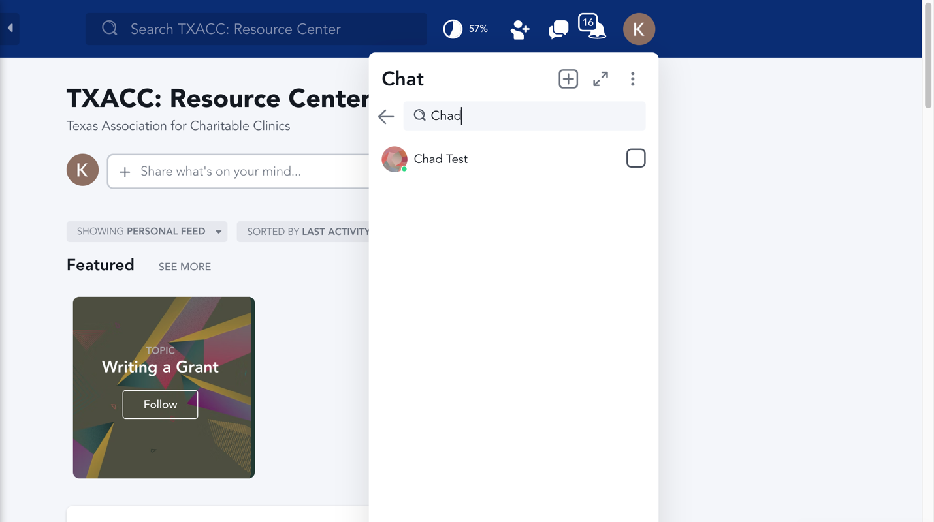

1. Next, click on “Start Chat”.

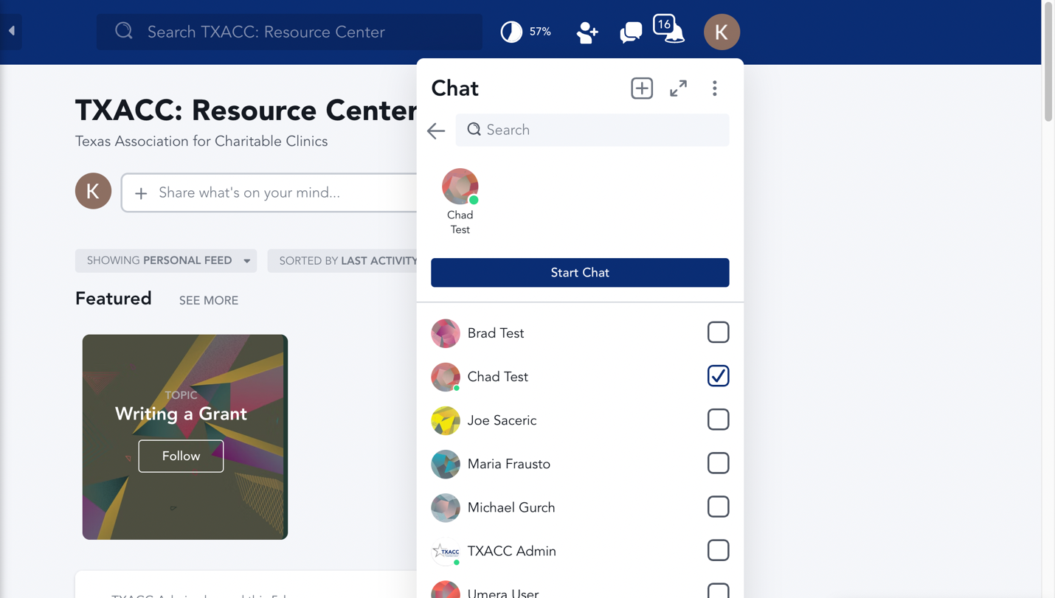

1. The direct message room is now created.

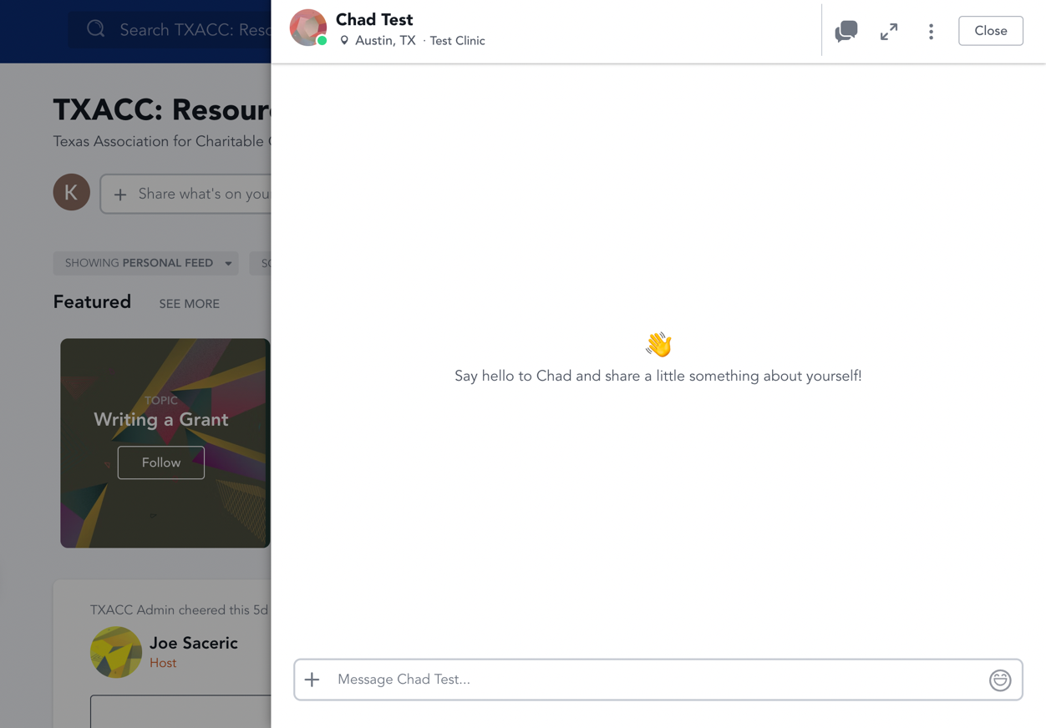

How to search for Resources via search bar

1. Navigate to the [TXACC Mighty Network](https://txacc-resource.mn.co/feed)
2. There should be a search bar at the top. Type in the name of the resource category you want to search for

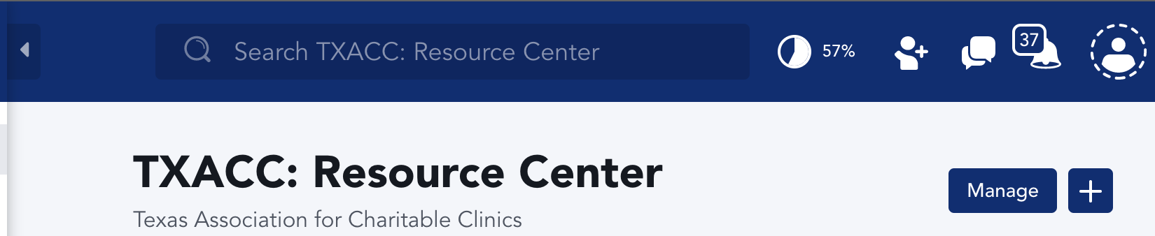

1. Click on the resource category you want to access

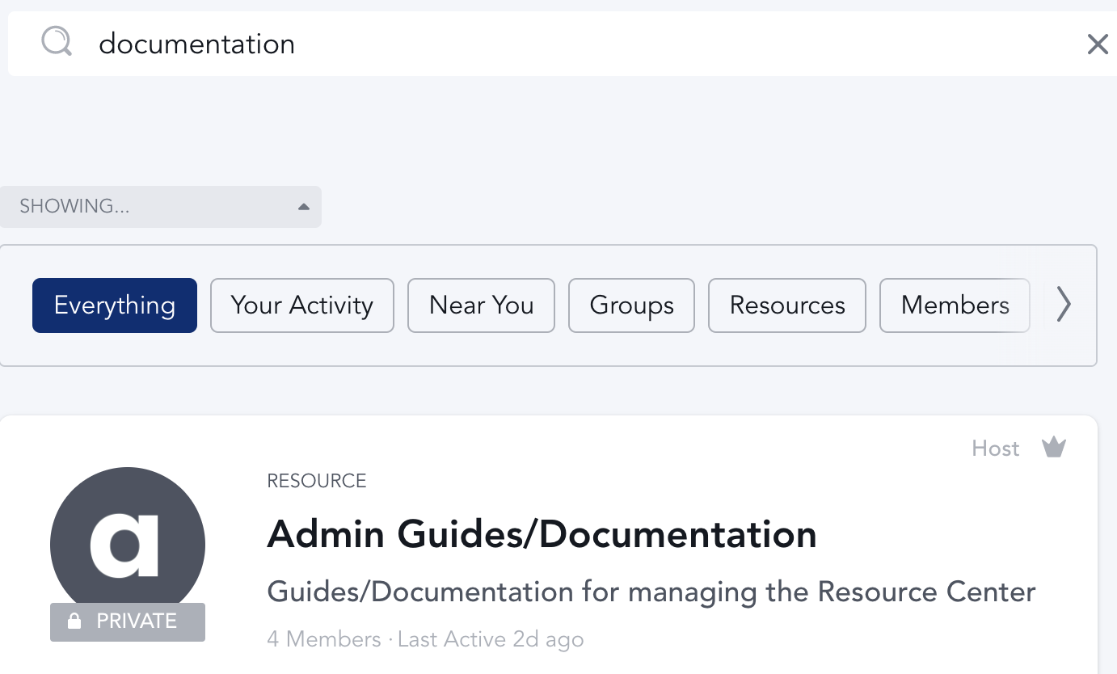

To search for files

1. There should be another search bar at the top. You can search for files/resources here.

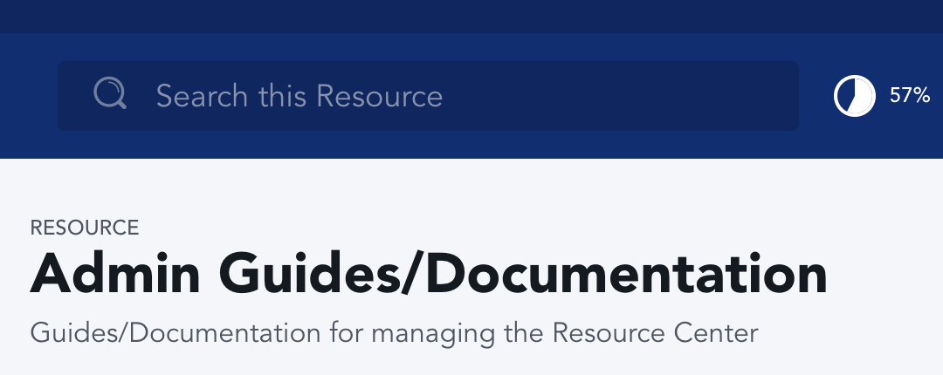

1. Here’s an example of searching for “Add files”:

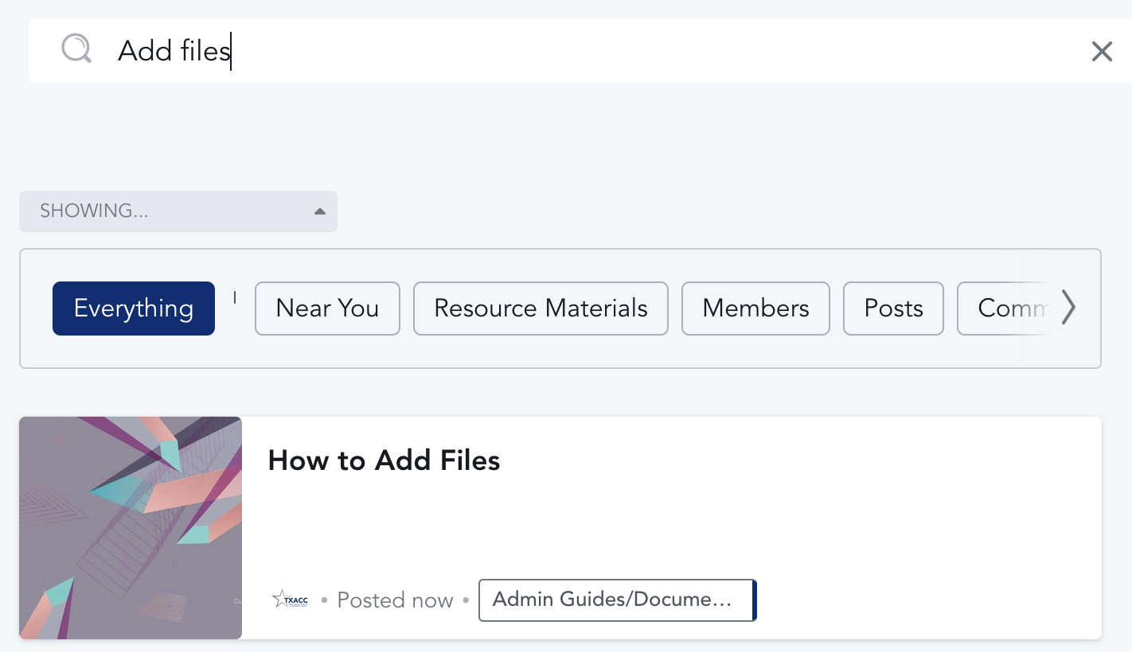

How to filter Resources

1. Navigate to the [TXACC Mighty Network](https://txacc-resource.mn.co/feed)
2. Click on “Resources” on the left pane

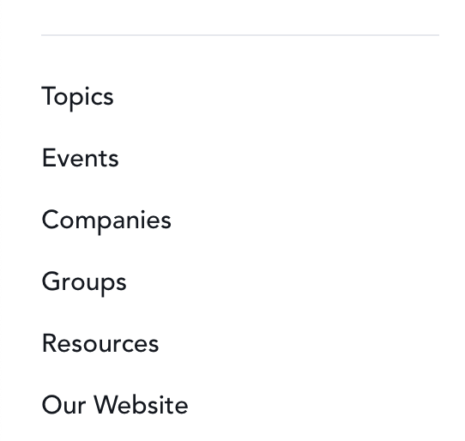

1. You can search and filter by the boxes near the top

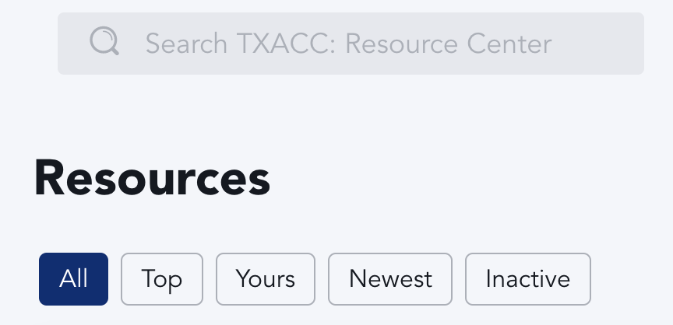

How to Search for Clinics and their Members in the Resource Center

1. Navigate to the TXACC Resource Center Homepage: <https://txacc-resource.mn.co/feed>
2. Select the “Companies” tab on the left-hand side of the screen

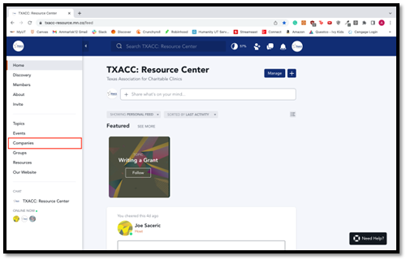

1. Once inside of the “Companies”, you will see all of the clinics that all members are a part of. Go the search bar located at the top of the screen and type in the name of the clinic that you are looking for.

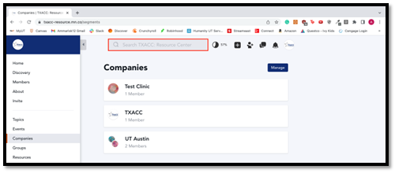

1. When you type in the name of the clinic, you will see some search results appear below, as well as a section to filter you search results. Click through the filters and find the “Companies” filter to narrow your search down.

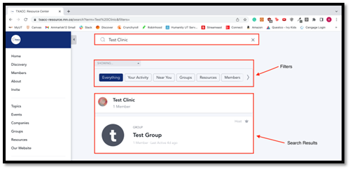

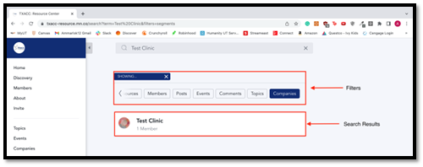

1. Once you have narrowed your search results, click on the name of the clinic to see which members are a part of the clinic.

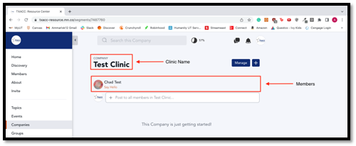

How to send a mass announcement

1. Navigate to the TXACC: Resource Center Homepage: <https://txacc-resource.mn.co/feed>
2. Click on the bar that says “Share what’s on your mind”

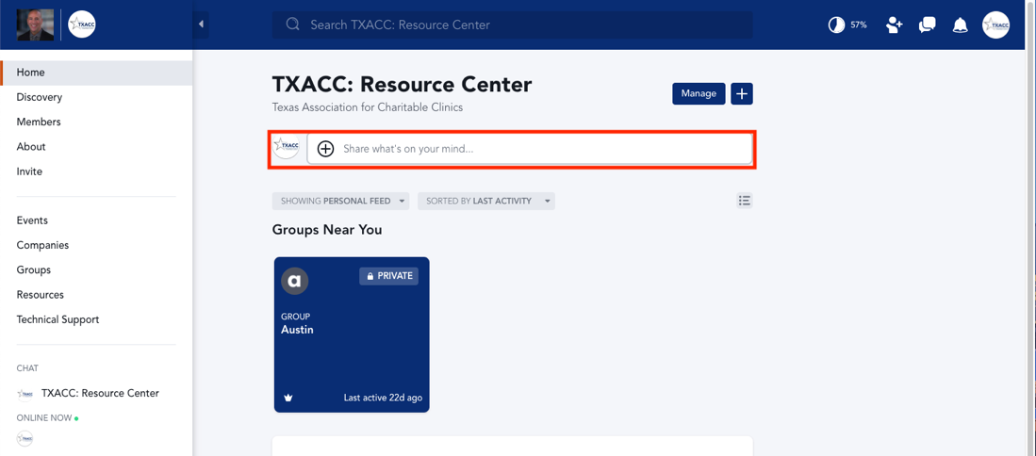

1. Type your message and click “Post”

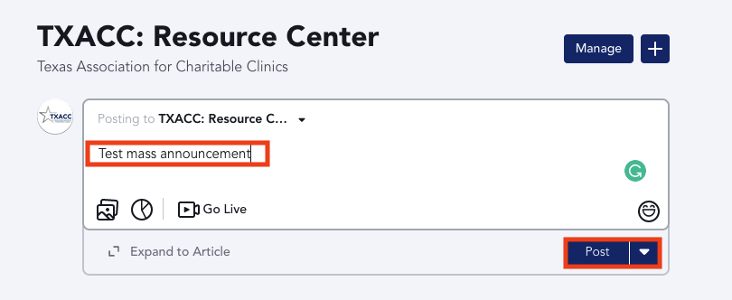

How to manage your notification preferences

1. Navigate to the TXACC: Resource Center Homepage: <https://txacc-resource.mn.co/feed>
2. Select the notification bell at the top right of the screen

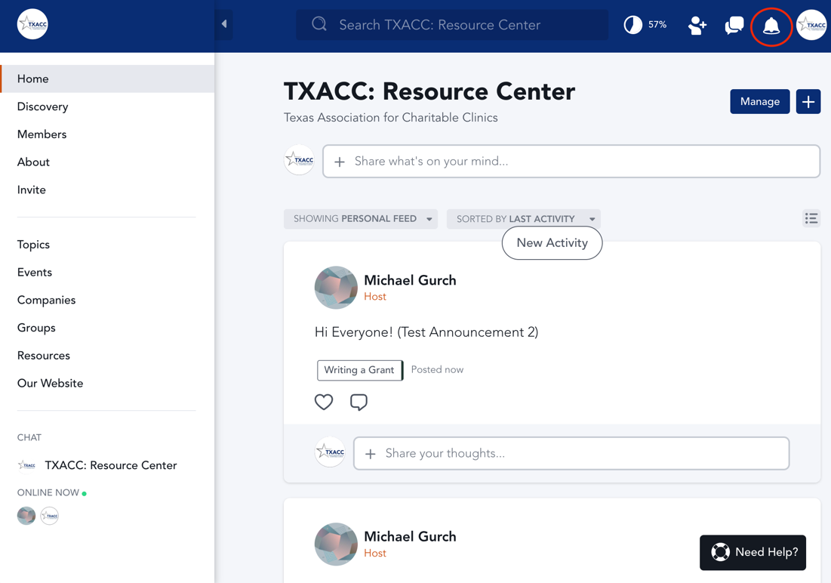

1. In this window, you will see all of your notifications. Click on the Settings Gear Icon at top of the window to open your notification settings.

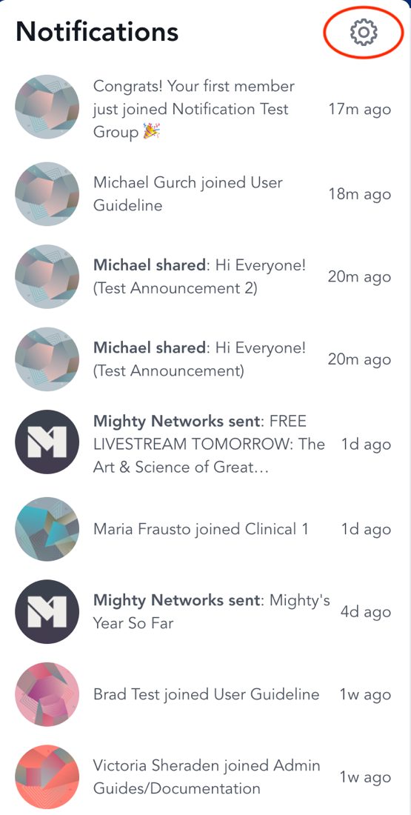

1. In this window, you will see a list of notification settings that can be turned on and off. We recommend having email notifications and mobile notifications on. We also recommend the “Daily Digest” option for Email Frequency so that your inbox is not flooded with messages.

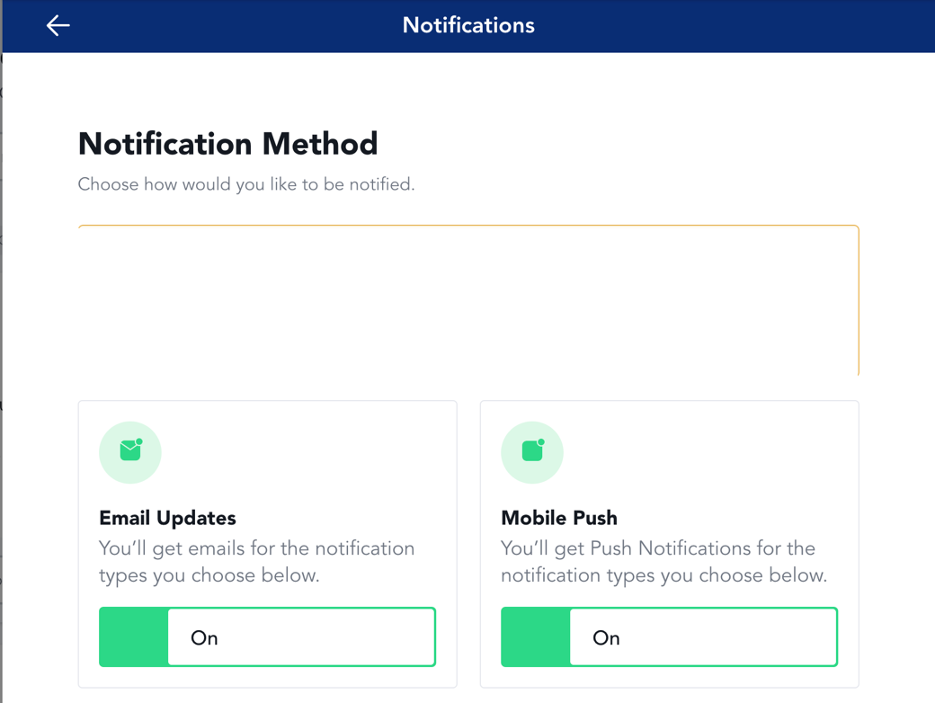

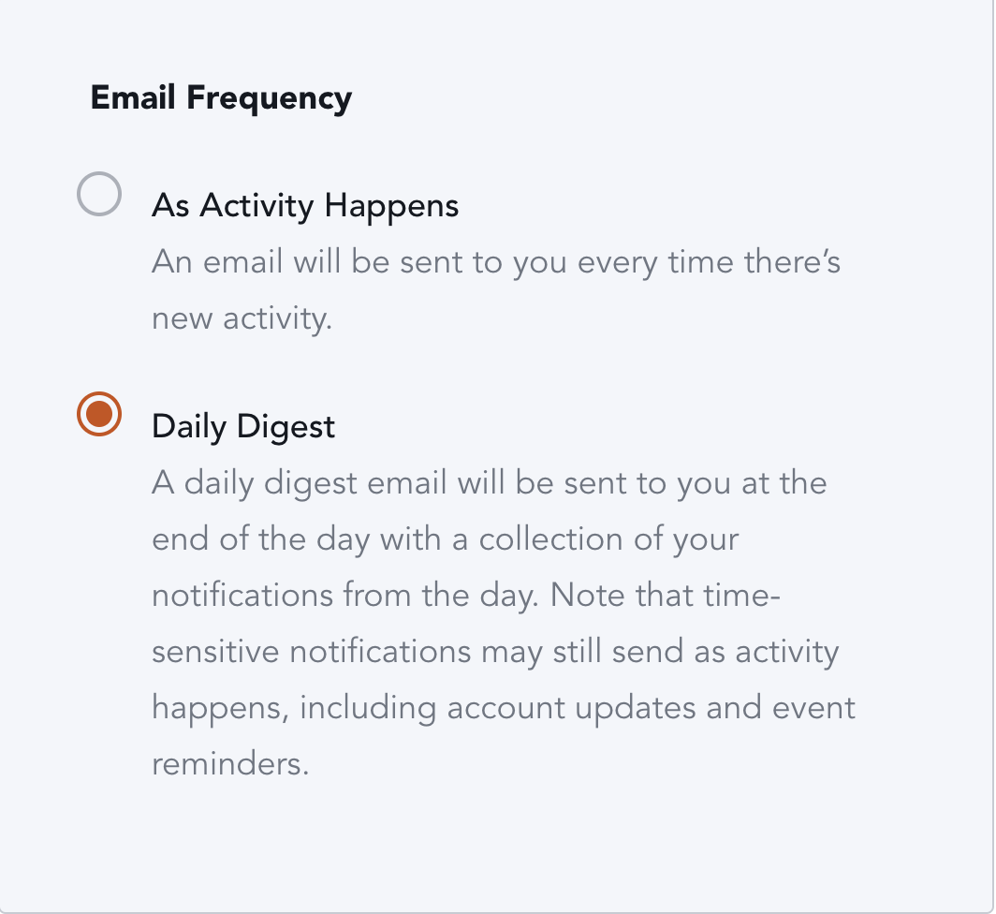

1. For the “Notification Types” section, most of these will be on and we recommend leaving them on so you are updated on the activity of the resource center

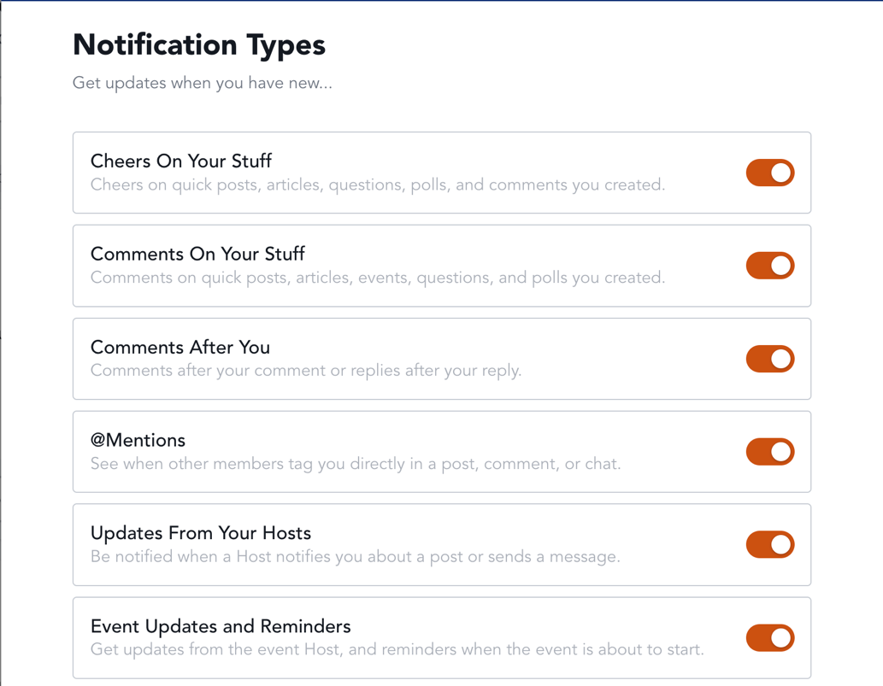

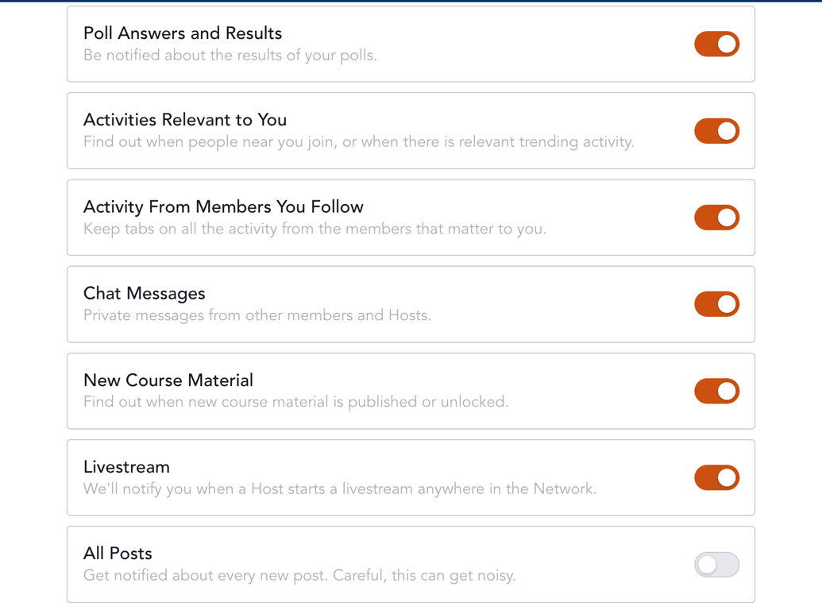

1. For the “Group and Resource Notifications” section, we recommend having these notifications on as well. You will only see the Groups and Resources that you have access to.

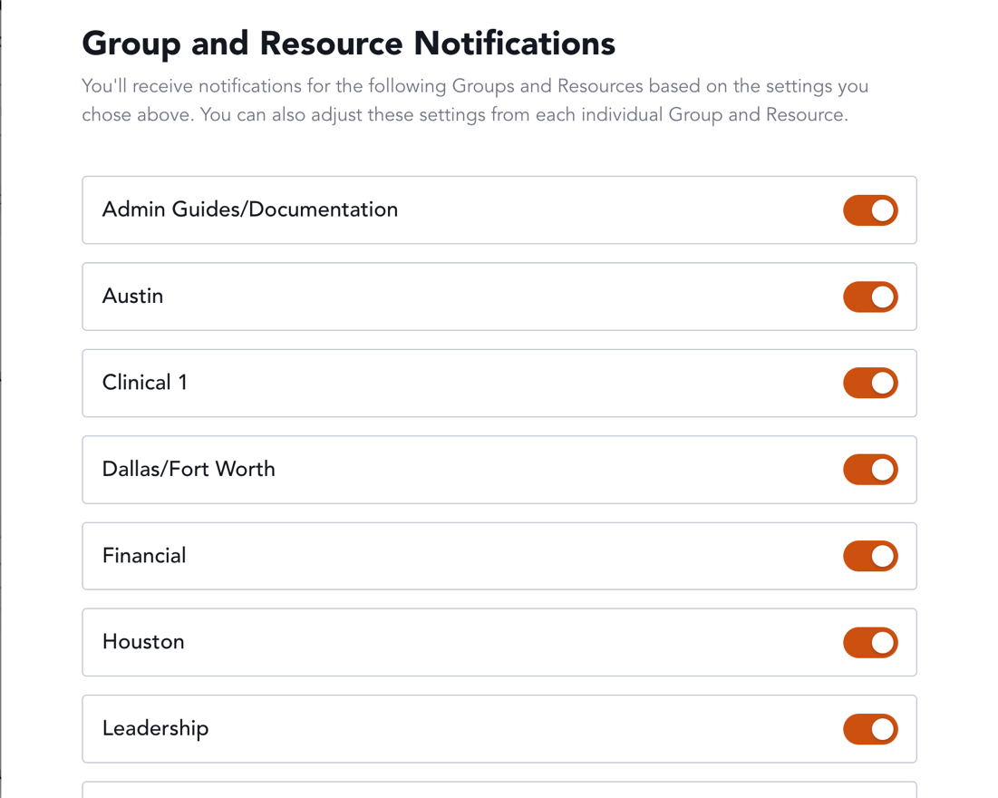

How to request for IT help

1. Navigate to the [TXACC Resource Center](https://txacc-resource.mn.co/feed)

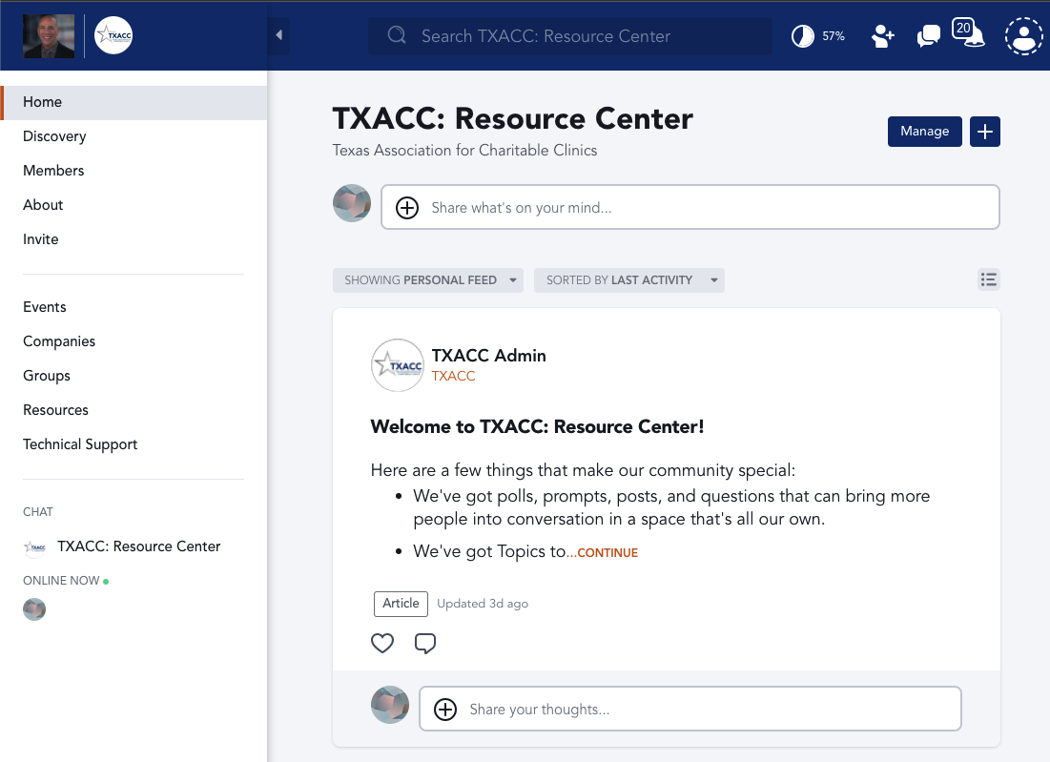

1. Next, click on “Technical Support” on the left nav bar

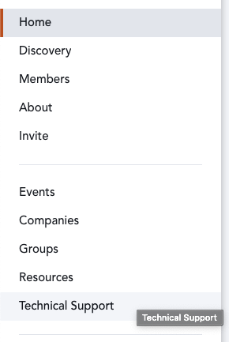

1. Click on the “Share what’s on your mind…” text box and type in your question!
   1. NOTE: it’s helpful to mention one of the TXACC Admins such as “Umera Khan”
      1. You can do this by typing “@Umera Khan” and there should be a popup with her name

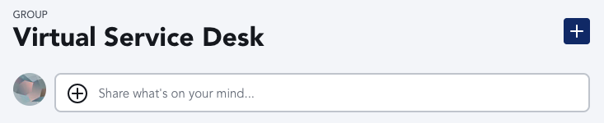

1. After you have typed in your question, simply click on “Post” on the bottom right.

